Abstract of thesis entitled

A Usability Study of a Language Centre Web Site

submitted by Andrew J. Morrall for the degree of Master of Science in Information Technology in Education at the University of Hong Kong, September, 2002.

A usability study of the Internet site of the Centre for Independent Language Learning (CILL), a part of the English Language Centre (ELC) at the Hong Kong Polytechnic University (HKPU) was carried out in June and July 2002. The purpose of the research was to investigate whether the technique of ‘Discount Usability Testing’ advocated by Nielsen (1994, pp. 245-272) is effective in improving the usability of the CILL Internet site, given its departures from the ‘classical’ experimental approach as detailed in Rubin (1994), such as a small number of test subjects.

This overall question was divided into three. Firstly, do the improvements to the site made during the usability study result in improvements in test participants’ success rate in completing tasks on the CILL site? Secondly, do the improvements to the site made during the usability study result in participants being able to carry out these tasks in a shorter time? Finally, do the participants say that they believe that the site is easier to use?

In the research CILL members were questionnaired as to how they use the CILL site. From this information, ten test tasks were developed. Ten test participants, a mixture of CILL students and ELC teachers, including both native speakers of English and Chinese, then attempted these tasks. These tests were observed, and notes taken on usability problems with the site, whether the participant completed the task successfully, and how long the participant took to complete the task.

Nineteen modifications were then made to the site to try to eliminate the usability problems. Then more tests were held with the same test tasks and two groups of participants. The first group consisted of five participants who had taken the test in the first round of testing. The second group consisted of eight participants who had not done the first round. Again, these tests were observed, and notes taken on usability problems with the site, whether the participant completed the task successfully, and how long the participant took to complete the task.

The small number of test participants made it difficult to reliably answer research questions one and two. However, given this, the statistics indicate improvements in both task success rate and reductions in task completion time. For research question 3, of the five participants who re-took the test, one strongly agreed that it was easier, one agreed, and three neither agreed or disagreed. Thus, on these criteria, and with these limitations, ‘Discount Usability Testing’ was an effective methodology for improving the usability of the CILL Internet site.

Further research is recommended into using more authentic tasks such as a text correction task, investigating the effects of testers and participants reading the task instructions aloud, the effect of participants’ level of computing skills on their task success and duration, and the optimum number of participants to test between site design iterations.

In addition, as the aims, users and content of educational web sites are different, it is recommended that webmasters of such sites carry out usability studies to investigate the effectiveness of this methodology and how their sites could be improved.

A Usability Study of a Language Centre Web Site

Andrew J. Morrall

A dissertation submitted in partial fulfilment of the requirements for

the Degree of Master of Science in Information Technology in Education

at The University of Hong Kong

September, 2002

Declaration

I declare that this dissertation represents my own work, except where due acknowledgment is made, and that it has not been previously included in a thesis, dissertation or report submitted to this University or to any other institution for a degree, diploma or other qualification.

Signed: ______________

( Andrew J. Morrall )

Acknowledgments

I would like to thank my supervisor, Mr. Albert Chieng, for the valuable advice and support he has given me in the writing of this dissertation. I would also like to thank the questionnaire respondents and the test participants for their co-operation and efforts. My thanks also go to the staff of the English Language Centre of the Hong Kong Polytechnic University for their assistance, encouragement and co-operation. My deepest thanks go to my wife and son, for their love, understanding and support.

Table of Contents

Table of Contents vi
1. Introduction 1
1.1 Purpose 1
1.2 The Background to the Research 1
1.3 Research Questions 1
1.3.1 Research Question One 1
1.3.2 Research Question Two 2
1.3.3 Research Question Three 2
1.4 Profile of CILL 3
1.4.1 CILL Students 5
1.4.2 CILL Attendees 5
1.4.3 ELC Students 5
1.4.4 Other HKPU Students, Staff and Alumni 6
1.4.5 Non-HKPU Students (Including International Visitors) 7
1.4.6 CILL Teachers 7
1.4.7 Profile of the Researcher 7
1.4.8 Profile of the CILL Internet Site 8
1.4.9 Navigating the CILL Internet Site 9
1.4.10 Content of the CILL Internet Site 10
1.5 The Need for the Research 11
1.6 Scope 11
2. Literature Review 13
2.1 Introduction 13
2.2 Advantages of the Internet for Independent Language Learning 14
2.3 User-centred Design 18
2.4 Definitions of Usability 19
2.4.1 Learnability 20
2.4.2 Efficiency 20
2.4.3 Memorability 20
2.4.4 Errors 21
2.4.5 Satisfaction 21
2.5 Experimental Method 22
2.6 Usability Heuristics 23
2.7 Heuristic Evaluations 26
2.8 Interface Evaluation 27
2.9 Iterative Design 29
2.10 Usability Testing 31
2.11 Questionnaires 32
3 Methodology 33
3.1 Reliability 33
3.2 Validity 34
4 Findings 36
4.1 Overview 36
4.1.1 Summary of Research Question One: Task Success Rate 36
4.1.2 Summary of Research Question Two: Task Duration 38
4.1.3 Research Question Three: Ease of Use of the Site 39
4.2 The Initial Questionnaire 40
4.3 Piloting 41
4.4 The Usability Tests 46
4.4.1 The First Round of Testing 46
4.4.2 The Second Round of Testing 47
4.8 The Tasks and the Treatment: Changes made to the Site 50
Question 1 50
Question 2 54
Question 3 56
Question 4 58
Question 5 60
Question 6 64
Question 7 66
Question 8 74
Question 9 76
Question 10 78
4.6 Test 1 Totals 81
4.7 The Post-test Questionnaire 81
4.8 Summary of the Findings as Related to the Research Questions 82
5 Discussion 84
5.1 Changes to the Site 84
5.2 Reliability 85
5.2.1 Low sample size 85
5.2.2 Timing Method 88
5.3 Validity 89
5.3.1 Task Wording 89
5.3.2 Task Authenticity 90
5.3.6 Measuring and the Effects of Participants’ Computer Skills 94
5.4 An Alternative to Testing in Rounds 98
6 Conclusions 100
6.1 Results of the Study 100
6.2 Limitations of the Study 101
6.2.1 The Small Number of Tasks in Relation to the Size of the Site 101
6.2.2 The Small Number of Design Iterations 101
6.2.3 Problems in Debriefing Participants 102
6.2.4 Language Ability 103
6.3 Recommendations for Further Study 104
References: 105
Appendices 107
Appendix One: CILL Website Improvement Questionnaire 107
Purposes 108
Test Objectives 108
User Profile 108
Test Environment and Equipment 109
Appendix Three: Test Script 110
Appendix Four: Consent Form 111
Appendix Five: The Post-test Questionnaire for Round One 112
Appendix Six: The Post-test Questionnaire for Round Two – Repeating Participants 113
Appendix Seven: The Post-test Questionnaire for Round Two – New Participants 114

List of Tables

Table 1: Severity of Usability Problems 28
Table 2 : A Comparison of Task Success Rate for Participants who took Both Rounds of Tests (n=5) 37
Table 3: A Comparison of Task Success Rate between Participants who took part in Rounds One or Two Only 37
Table 4: A Comparison of the Mean Task Durations for Participants who took part in Both Rounds (n=5) 38
Table 5: A Comparison of the Mean Task Durations for Participants Who Took Round One or Round Two 38
Table 6: Analysis of Responses to Question 7 of the Initial Questionnaire 43
Table 7: Responses to Question 7 and Resulting Tasks 44
Table 8: Summary of Improvements 81
Table 9: Confidence that Task Performance Improved 86
Table 10: Summary of Improvements for Students 92
Table 11: Summary of Improvements for Native Speakers of Chinese 93

List of Figures

Figure 1: Screen shot of the CILL Home page on 12 June 2002…………………………..……….8
Figure 2: The Grammar page for the first test..………………………………………..………...51
Figure 3: The Grammar page for the second test......……………………………………..……...52
Figure 4: Question 1 Statistics.....…………………………………………………………….……53
Figure 5: Link to the Pronunciation page on the Speaking page.………………………………54
Figure 6: Question 2 Statistics.………………………………………………………………….…55
Figure 7: Question 3 Statistics.…………………………………………………………………….56
Figure 8: Question 4 Statistics.…………………………………………………………………….59
Figure 9: Site search engine results for 'Interview'.…………………………………………....61
Figure 10: Question 5 Statistics.…………………………………………………………………...62
Figure 11: Question 6 Statistics.…………………………………………………………………...64
Figure 12: Changes made to the page 'Reference Machine - Books'.………………………..….68
Figure 13: Question 7 Statistics.…………………………………………………………………...70
Figure 14: Screen shot of the Reference Machine Page, with instructions Highlighted…..71
Figure 15: The Reference Machine page as a route to in-text citations or bibliographical referencing.………………………………………………………………….....………72
Figure 16: Question 8 Statistics.…………………………………………………………….……..75
Figure 17: Question 9 Statistics.……………………………………………………………….…..76
Figure 18: The Reading page in the first round of testing.……………………………….…….77
Figure 19: Question 10 Statistics…………………………………………………………………..78
Figure 20: The links to the newspaper reading skills site in the second test………………..79
Figure 21: The Find Function………………………………………………………………………..95

1. Introduction

1.1 Purpose
The purpose of the research is to investigate whether the technique of ‘Discount Usability Testing’ advocated by Nielsen (1994, pp. 245-272) is effective in improving the usability of the CILL Internet site.

1.2 The Background to the Research
This research is about improving the usability of the Internet site of the Centre for Independent Language Learning, which is an independent English language learning centre and part of the English Language Centre of the Hong Kong Polytechnic University. I am the unofficial webmaster of this site. This research is a formative evaluation of the CILL web site (Nielsen 1993, p.170).

1.3 Research Questions
Is ‘Discount Usability Testing’, given its departure from the ‘classical’ experiment approach as detailed in Rubin (1994), such as the small number of test subjects, and non-random selection of subjects, effective in improving the usability of a site? My hypothesis is that it is not effective.

This overall question can be divided into three.

1.3.1 Research Question One
Do the improvements to the site made during the usability study result in improvements in test participants’ success rate in completing tasks on the CILL site?

1.3.2 Research Question Two
Do the improvements to the site made during the usability study result in participants being able to carry out these tasks in a shorter time?

1.3.3 Research Question Three
Do the participants say that they believe that the site is easier to use?

One of the reasons for researching this approach to web site design is that many educational organisations may have web sites run by individuals such as myself. These individuals, who are not usually computer professionals, wish to, or are under pressure to systematically review the sites that they are responsible for and show evidence of their quality. Such individuals may have very limited resources. For example, in CILL we have to produce an annual report to the University Grants Committee, our funding body, that describes what we have done to maintain and improve the quality of our teaching.

The reason that my hypothesis is that discount usability testing is not effective is that it cannot be said to be effective until it is shown to be so, for example if the results of the usability tests after the treatment – the changes to the design of the site – are effective in improving the performance of the test participants.

It could be argued that the small sample size of participants testing the site means that the validity and reliability of the experiment are in doubt and that therefore the results are meaningless. This is why the post-test questionnaire of the group of participants who tested the first and second version of the site were asked whether they think that the site is easier to use.

1.4 Profile of CILL

The Centre for Independent Language Learning is a self-access centre for students to learn English. Organisationally it is a part of the English Language Centre of the Hong Kong Polytechnic University.

The name Centre for Independent Language Learning reflects the teaching philosophy of the centre, in that students are encouraged to learn ‘independently’. This philosophy follows the writings of Holec, who describes a change since the 1960’s from a view of man as a ‘product of his society’ to man as a ‘producer of his society’, and the role of adult education as having the objectives of equal opportunities, responsible autonomy, personal fulfilment and the democratisation of education. He defines autonomy as "the ability to take charge of one’s own learning." Holec (1981, p.3).

Sheerin (1997, p.56) describes a general belief among many language educators (e.g. Nunan, 1997; Pemberton et al., 1997; Littlewood: 1981; Ur, 1988 ) that "learning is more effective when learners are active in the learning process, assuming responsibility for their learning and participating in the decisions that affect it."

One of the aims of the CILL Internet site is to promote these ideals, for example by helping learners become more active in the learning process through their participation in syllabus design to evaluation process. Learners can use the advice on planning their work, the learner pathways, the lists of materials for common learner needs, on-line learning materials, and the information on self-assessment of their work that are available on the CILL site.

Learners are encouraged to assume responsibility for their own learning by taking part in the above process, and also by being responsible for the frequency, duration and pace of their studies. The CILL Internet site is on-line and available to learners 24 hours a day to facilitate this.

CILL has a physical centre as well as an online one. CILL policy is that students should join and attend voluntarily. About one-third of students at the university are members.

It should be emphasised that CILL is not a type of library. Although there are superficial similarities such as the collection of books and magazines for students to read, it differs from a library in that a teacher is available for students to consult and learn from. A teacher is made available because learners progress from dependence towards independence, and a teacher is necessary to help in this process (Sheerin 1997, p.57). Even very independent students may independently decide that consulting a teacher is the most efficient strategy in certain situations.

Similarly, the CILL Internet site is not similar to a library web site. For example, it is not an index to materials held in CILL, although some of these are listed on the site. The main function of the CILL site is to help students to improve their English, and therefore the site contains materials such as online exercises, grammatical explanations, and learning advice that are not usually found on library web sites. In short, CILL and its Internet site provide teaching about content, in this case about English.

1.4.1 CILL Students
A wide variety of students are eligible to become members of CILL. They include, in order of numbers, all Polytechnic University undergraduates, postgraduates, members of the alumni association, and students on short courses such as English teachers studying for the language benchmark test. The web site is also visited by HKPU staff and non-HKPU students, including international visitors.

1.4.2 CILL Attendees
CILL attendees are those who visit the physical centre. Many are introduced to the Centre by their teachers, who bring them on tours. Those who attend after these tours are required to join the centre by undergoing an orientation, during which they receive a booklet on the Centre which includes the web site address. Approximately 3,000 new members enroll each year.

1.4.3 ELC Students
All undergraduate students, whether taking a Higher Diploma or a Degree, take the ELC’s English for Academic Purposes (EAP) course. About 7,000 students study this course each year. This course includes assessments on a short piece of academic writing of approximately 250 words, a longer piece of writing of about 500 words, and an individual oral presentation. The longer writing task includes writing a bibliography in American Psychological Association (APA) format. To help the students with this task, the CILL site has materials such as the reference machine at http://elc.polyu.edu.hk/cill/referenceMachinebooks.htm , which automatically constructs correctly formatted references as students fill in boxes with book details. There are also instructions on referencing and exercises to help the students become familiar with the conventions and format of APA references, for example at http://elc.polyu.edu.hk/cill/exercises/intextrefs.htm . One of the usability study tasks was to find and use referencing materials.

1.4.4 Other HKPU Students, Staff and Alumni
CILL is also open to students studying higher degrees such as MAs, MPhils and PhDs. Many of these students are from mainland China, and have different needs from Hong Kong students.

These needs are similar to some HKPU staff such as research assistants, who are also sometimes mainlanders. All HKPU staff are eligible to join CILL. The referencing pages mentioned above are also useful for post-graduate students, who are often required to write theses or projects that involve referencing. There are also lists of CILL books that are useful for writing research papers, for example at http://elc.polyu.edu.hk/cill/DATAMATS.HTM .

There are also a number of part-time students who are members of CILL. These include those studying MAs in English Language Teaching, those studying at the HKPU's Centre for Professional and Business English (CPBE), and a number of English teachers studying in-service professional development courses.

CILL is also open to members of the HKPU Alumni Association. Although CILL membership is mostly voluntary, CILL membership is included in some CPBE courses.

1.4.5 Non-HKPU Students (Including International Visitors)
The CILL web site is not an intranet, nor is a password needed for access. Therefore people who are not eligible to be members of CILL can use the site. The site has many international visitors. For example, in March 2000 there were visits from 39 countries, with Hong Kong being the most common, followed by the UK (23 visitors), Singapore (21), Australia (18) and Malaysia (17).

However, only CILL members are entitled to the online support provided, such as the e-mail advice. The site is designed and the content is written for CILL members, for example there are pages describing the books in CILL that are relevant to learning various topics in English, and these books are only available to CILL members.

1.4.6 CILL Teachers
CILL has a teaching staff of seven, who spend between 6 and10 hours per week, or up to half their teaching hours, teaching in CILL. The rest of their teaching hours are spent teaching courses for the English Language Centre. There is a Senior Lecturer, a Lecturer and five Language Instructors. I am one of the Language Instructors.

1.4.7 Profile of the Researcher
CILL administration duties are divided between the CILL staff, and I am responsible for the CILL web site. Initially the site was set up by a technician, but for the past seven years I have designed, written, programmed and maintained the site. Although I lack formal computer qualifications, my MA in English Language Teaching included a course on programming in Visual Basic, and I am now studying the MSc[ITE]. As a professional educator working in the area of independent learning I have also researched the field of Internet design and usability, including pedagogical issues in web-based education, as well as learning HTML, Java and JavaScript.

1.4.8 Profile of the CILL Internet Site
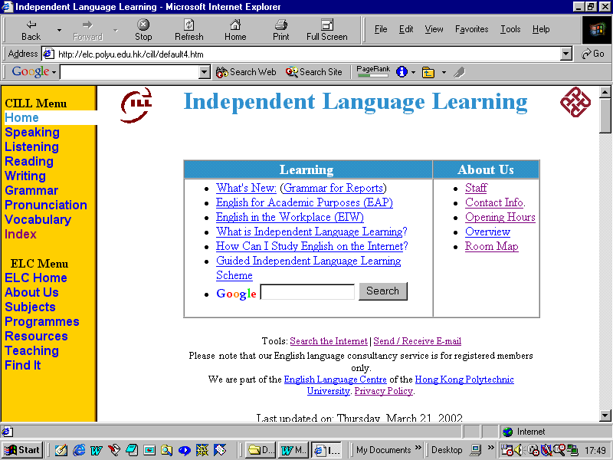
The URL of CILL is http://elc.polyu.edu.hk/cill/ . Figure 1 shows a screen shot of the home page on 12 June 2002. The vertical orange menu bar on the left contains links to CILL pages and ELC pages. At the top of the page are the CILL logo and the University logo, and between them is the page title. In the centre of the page is a table containing information about learning in the left column and about the centre in the right column. The left column contains standard home page links such as to the What’s New page and the Search function. There is also information on independent language learning, and on two ELC courses, English for Academic Purposes and English in the Workplace. These courses are taken by most Polytechnic University students, and the CILL site has sections devoted to supporting these courses. There are course-related materials such as interactive online versions of course book exercises, and course-related language proficiency materials, for example explanations and exercises on common grammatical mistakes made by students on these courses.
Figure 1: Screen shot of the CILL Home page on 12 June 2002.

1.4.9 Navigating the CILL Internet Site
There are three ways to find a page on the CILL site. Firstly, users can follow the links, for example if users wish to study grammar, they can click on the Grammar link in the orange menu bar.

Secondly, users can use the Search function at the bottom of the table in the middle of the page. This uses the site search facility of the Google search engine to search the CILL and ELC internet pages for the users’ search terms.

Finally, users can use the Index link in the yellow menu bar to go to the Index page, which contains an A-Z listing of all the CILL pages. Clicking on the links in this listing will take users to the pages they are looking for.

In addition, the course books used on the ELC’s English courses contain internet links for students to follow for extension and consolidation of material they have learned in class. These links include links to pages on the CILL site, and individual class teachers can decide whether to ignore, recommend, or set these pages as homework.

1.4.10 Content of the CILL Internet Site
The CILL site contains a wide variety of types of content. These types include, explanations, exercises, simulations, cognitive tools, language learning tools and tools for teachers.

Examples of explanation pages are the pages ‘What is Independent Language Learning?’ at http://elc.polyu.edu.hk/cill/whatsILL.htm and ‘How Can I Study English on the Internet?’ at http://elc.polyu.edu.hk/CILL/FAQ.htm.

Examples of exercise pages, which often also contain an explanation before the exercise are ‘Staff or Staffs’ at http://elc.polyu.edu.hk/CILL/exercises/staff.htm and the ‘Job Interview Quiz’ at http://elc.polyu.edu.hk/CILL/exercises/jobinterviewquestions.htm both of which were part of the usability tests.

An example of a simulation is the Sick Building Syndrome Office Design Game,
at http://elc.polyu.edu.hk/cill/sbs.htm , which helps students to learn about Sick Building Syndrome in preparation for writing a report about this topic in the English in the Workplace course.

Examples of cognitive tools are the Organisation Tool at http://elc.polyu.edu.hk/cill/
tools/orgtool.htm for organising and prioritising ideas, and the Idea Web for mind-mapping at http://elc.polyu.edu.hk/cill/tools/ideaweb.htm .
Language learning tools range from a simple link to a text-to-speech engine on the pronunciation page at http://elc.polyu.edu.hk/cill/pronunci.htm , to allow students to listen to words that they don’t know how to pronounce, to complex programs such as the fill-in-the-box job application letter writer at http://elc.polyu.edu.hk/CILL/jal.htm Both of these pages were also in the usability test tasks.

Tools for teachers include assessment grading and feedback tools such as the one at
http://elc.polyu.edu.hk/cill/quickcomment-eiw.htm .

1.5 The Need for the Research
CILL has had a web site since 1996. Although the site is constantly developing there has been little feedback from users on the design or content of the site. In addition, although the design of the site is based on the principles of independent language learning, there has been no formal research into its design or use, except for one conference presentation by the author. In addition, the University authorities are placing increasing emphasis on quality control and ELC management are planning a formal evaluation of CILL. Therefore it would appear pro-active if a member of CILL's staff were to formally research the design and use of the CILL site, and implement any improvements needed.

1.6 Scope
The research is limited to the CILL site, and the number of test subjects used will be limited, following Nielsen’s (1993, p.173) claims about the effectiveness of discount usability testing with small sample sizes.

This research does not examine the effectiveness of the teaching materials on the site, or whether the users' English language ability improves through the use of the site. This is because, firstly, examining such issues would make the scope of the research too broad to treat in sufficient depth, and secondly because it would be difficult to prove that the CILL site was the exclusive cause of any such gains in proficiency. This is especially because many of the materials on the site, for example the exercises, are interactive versions of materials published by the ELC and used on ELC courses.

2. Literature Review

2.1 Introduction
In this section the literature on usability testing will be reviewed, justifications for discount usability will be examined, its suitability to the CILL site context will be discussed, and its methodology explained.

There is no research on how can an Internet site be designed for independent English language learners. This may be because web site design for independent English language learning sites is a relatively new field. Although authors such as Nielsen (2000), and to a lesser extent, Krug (2000) have written extensively on web site design, emphasis tends to be placed on design for e-commerce. Little has been written on web site design in education. It remains to be seen whether the recommendations of these authors on general and e-commerce web design are transferable to education.

It should be mentioned at the outset that this research does not use a ‘pure’ or ‘strong’ version of discount usability theory. This is because the techniques suggested by Nielsen et al. have been modified to fit into the context of the research, for example because of the limited budget, personnel and facilities available. For example, Nielsen (1993, p. 172) claims that the “value of finding a usability problem in a medium-sized project can be taken as $15,000”, with a fixed cost of “$3,000 and variable costs of $1,000 per test user”. As this sum is in American dollars it is beyond the budget for this research project, and may well be beyond the budgets of other academics responsible for the quality of their organisations’ Internet sites. However, it is hoped that, as limitations such as these will commonly be encountered by such staff, the following account of a low-budget, limited-resource discount usability study will be useful.

2.2 Advantages of the Internet for Independent Language Learning

The use of the Internet for independent language learning gives rise to a number of advantages, but it also has a number of problems that mean that it cannot replace the role of teachers.

A major advantage of using the Internet in education is convenient access to information. Students may find that using the Internet from home, at university, or increasingly, from Internet-connected devices such as mobile phones and Personal Digital Assistants, is more convenient than going to a library or to CILL, with their limited opening hours, difficulties in finding a seat and limitations and expenses for copying.

A second major advantage is individualisation (Forsyth 1998, p50). Students have different abilities and different needs, but often study in groups, for example in classes and lectures. It is difficult for teachers in class or in lectures to target information to individual students. However, on the Internet it is possible for students to control the content, time, pace and learning style they use. Thus they can learn the content that they wish to know, at a depth to which they choose. They can study at the time they want and at a pace that suits them (Eklund, 1995; Taylor 1980, p.60). They can also use a learning style that suits them, for example different students have different preferences about communicating and learning with others, which can be done on the Internet with e-mail and instant messaging programs such as ICQ. Advice on learning styles is provided on the CILL site at http://elc.polyu.edu.hk/CILL/styles.htm . Students can also use studying strategies that they prefer, rather than ones ordained by the teacher in classroom activities. For example, some students like to take linear notes, but others prefer mind-maps. Advice on strategies is available at http://elc.polyu.edu.hk/CILL/strategy.htm .

The third major area in which the Internet is useful for education is in communicating with other learners and teachers. This can range from e-mail to bulletin board systems and discussion programs. These are often asynchronous, so learners can research and plan the content and language of their contributions and responses to messages before uploading them, in contrast to the in-class or seminar situation where students are often asked to contribute with less planning and thinking time. Such computer-mediated communication is analysed in more detail by Jonassen (1996, pp. 147-181).

A part of the Internet’s functionality as a communication tool is that it can be used as a forum for the publication of learners’ ideas and research, for example as pages on the Internet. These publications can also be modified in the light of feedback from teachers and other learners (Jonassen 1996, p.158). Such modifications can be made more easily than to publications on paper.

A fifth advantage of the Internet is that it can be used as a tool (Taylor 1980, p.3). Although Hyper-text Mark-up Language (HTML) does not function as a programming language, modern browsers such as Netscape Navigator and Internet Explorer usually understand scripting languages such as JavaScript and programming languages such as Java. Other plug-ins such as Macromedia Flash can also allow browsers to run programs. The advantage of such programs being on the Internet is in the ease of access to them, that they are usually free of charge, and the lack of installation procedures necessary to run them. An example of a language learning tool on the CILL site that uses JavaScript is the Scanner, at http://elc.polyu.edu.hk/CILL/tools/scanner.htm , which is a program that imitates a reader using the reading skill of ‘scanning’ to search a text for information. The program highlights the easy-to-find information. The user can then edit the organisation and content of their text to make it more reader-friendly.

However, there are also a number of areas in which the Internet is not a useful learning tool or has important limitations. Firstly, Internet pages have limited feedback abilities for language learning. For example, they cannot listen to a user’s voice and suggest pronunciation corrections. Computer programs in general, including those on the Internet, cannot hold a conversation and practice conversational moves. For this CILL students can talk to the teachers available in the CILL centre.

Secondly, not all information on the Internet is as trustworthy, compared, for example, to the edited information in academic journals and text-books which students can find in libraries, although a number of edited academic journals now have web sites, for example the New York University’s Journal for Online Education at http://www.nyu.edu/classes/keefer/waoe/waoej.html

Thirdly, there are limitations to the information available on the Internet. Access to some information may require subscriptions. Also, information available in academic journals is often unavailable on the Internet. Finally, using an Internet search engine to find information can be a long process, as lists of links may contain many irrelevant pages and sites that need to be viewed and judged before being discarded. When searching for academic information it may be more efficient to use off-line resources in a library or a facility such as CILL.

Fourthly, although broadband Internet access has increased the amount of information that some Internet users can receive per second, not all users have access to such high-bandwidth connections. Therefore the usefulness of the Internet for receiving multimedia information such as video is still limited. Also, CILL students may find that both the commercially-produced and the ELC’s in-house language learning video materials they wish to see are not available on the Internet, and may find it necessary to come to CILL to view such videos.

2.3 User-centred Design

Rubin (1994, p.11) describes user-centred design as the context for performing usability testing. He cites Gould and Lewis (1985), who suggest three principles for user-centred design. These are an early focus on users and tasks, empirical measurement of product usage, and iterative design, whereby a product is designed, modified and tested repeatedly. The design of this research project follows these principles in that it focuses on how a group of participants chosen from CILL web site users carry out tasks which a survey of a larger group of users has shown to be frequently done on the CILL site. The research empirically measures the participants’ performance on these tasks. This is done twice, once before and once after changes to the site. The results are then compared. The iterative design results in three sets of changes to the site. The first is done before the first user test to ensure that the site follows the usability heuristics suggested by the literature. The second iteration of changes is a result of the participants’ performance on the first user test and of suggestions made by these users in post-test questionnaires.

The final iteration of the site’s design is based on the usability problems found in the second round of testing, or changes to the re-design in the previous iteration that were not effective.

2.4 Definitions of Usability
Rubin (1994, p.22) says that usability testing “employs techniques to collect empirical data while observing representative end users using the product to perform representative tasks”. He describes an approach to usability testing, which “employs an iterative cycle of tests intended to expose usability deficiencies and gradually shape or mould the product in question.”

Nielsen (1993) describes the testing of an ‘interface’. Although an interface and web site are different things the web site is presented to a user through its interface. The interface consists of the screen contents through which the user or test participant and the computer and web site interact. Usability studies mainly concentrate on the user interface rather than on the internal workings of the program or the computer. Design changes made as a part or result of such studies may involve changes to the underlying programming of the computer, but these are usually invisible to the user, who only sees changes in the interface’s appearance or response speed. Therefore, to be precise, this research is a usability study of the interface of the CILL web site, which may, however, involve changes to the underlying site as well as to the interface.

According to Nielsen (1993, p.26), usability can best be defined in terms of its components as it is not a one-dimensional property of a user interface. Five attributes can help measure usability. These are learnability, efficiency, memorability, errors, and satisfaction.

2.4.1 Learnability
Learnability refers to how easily users can learn an interface. Interfaces can be designed for a range of users from novices to expert users.

Some CILL students are studying degrees in Computing, and therefore can be regarded as expert users. Other CILL users may have less experience. In the post-test questionnaire the students were asked about their experience at using the internet, using the internet for learning, using the internet for language learning, and using the CILL site for language learning. The CILL site is mainly designed with novice users in mind.

Learnability can be measured by giving users tasks and assessing how long it takes them to learn how to do these tasks.

2.4.2 Efficiency
Efficiency of use is similar to learnability, but the users measured are experts. Thus it measures how long expert users take to complete tasks. This expertise is assessed by defining users who have used the system for a certain number of hours as expert users.

2.4.3 Memorability
This measures the performance of another group of users, the casual users. Casual users are those who use a system intermittently, with weeks or months between uses. An interface should be memorable so that these users can return to the system and use it successfully either immediately, or learn to use it again very quickly.

2.4.4 Errors
The interface should restrict the user to few and non-catastrophic errors. Errors can be categorised on a scale of severity, from minor ones which the user corrects without help and in a short time, to major errors which cause long delays or loose data. User testing can help identify the causes of these errors. They can be categorised according to severity and frequency, and thus prioritised for remedy.

2.4.5 Satisfaction
This refers to the subjective satisfaction of the users. Nielsen (1993, p.35) suggests a number of questions to measure this aspect, and relevant questions from his list are used in the post-test questionnaire. Test subjects were asked to rate statements such as “Using this system was a very frustrating experience.” on a five-point scale. Nielsen quotes research that suggests that, due to the politeness of test subjects and their reluctance to criticise a system that they know a tester is involved in, the mid-point on a 5-point scale should be 3.6 rather than 3.

2.5 Experimental Method
Rubin (1994, p.28) contrasts ‘classical experiments’ with the usability testing method described in his book and followed in the methodology of this research. He outlines the classical experimental design as one of formulating hypotheses, using a randomly selected group of participants, using tight controls to ensure the validity of the results, using control groups and the need for a large sample size.

He goes on to comment on how this methodology may be inappropriate for the context of some organisations. He elaborates on this claim, for example, saying that it may be difficult to find a large enough sample of users to randomly select from.

2.6 Usability Heuristics
Nielsen (1993, p. 20) claims that these guidelines “can be used to explain a very large proportion of the problems one observes in user interface designs”.

The following heuristics were used to assess the usability of the CILL site.
- ‘Simple and natural dialogue’
In this heuristic Nielsen advocates conciseness and good organisation.
- ‘Speak the user’s language’
This does not mean that the site should be in Chinese, especially as the CILL site is an English language teaching site at a university which uses an English medium-of-instruction. It means that the language used should not be computer jargon, but words familiar to the user. This is not a straight-forward guideline to follow on language teaching sites because the users will have different language abilities, and users of similar levels know different ranges of vocabulary. This is therefore an area in which user-testing is of special importance.
- ‘Minimise the user’s memory load’
The example given is making instructions easily accessible. This heuristic may be especially important for CILL users as they already have the cognitive load of understanding the foreign language in which the site is written.
- ‘Consistency’
In English writing it is sometimes considered good style to vary the words used to describe something. For example, the Internet has the synonyms ‘the net’, ‘the web’, and ‘the information superhighway’. Nielsen warns against such variations, saying that “users should not have to wonder whether different words, situations or actions mean the same thing”. This may be especially true in web sites for language learners who may not have the breadth of vocabulary and ability to recognise synonymy that native speakers have.
- ‘Feedback’
Nielsen recommends keeping the user informed of the status and progress of any activity. On the Internet this is often done by the browser. On the CILL site feedback is given via forms, alert messages and information on pages. Usability testing is partly a test of the effectiveness of this feedback.
- ‘Clearly marked exits’
These allow users to exit a page or program without having completed it. Most Internet browsers have such exits as the Back button and the Home button. Web sites can have logos that are links to the site home page and navigation menus and breadcrumb trails to allow users to leave a page (Krug, 2000, p.61).
- ‘Shortcuts’
These are features for advanced users of a system. For example in many programs a user can press an icon of a printer to go to the print menu. However, advanced users can press Control-P on the keyboard, thus saving the time necessary to move the hand off the keyboard to the mouse and moving the mouse accurately to the print icon.
Such features can be included on web page, but the CILL site does not contain any as many are built into the browser. Such shortcuts can be written in JavaScript, but this increases the download time of the page. Usability testing and iterative design can be used to detect a need for and experiment with such advanced features.
- ‘Good error messages’
These, Nielsen writes, should inform the user of the nature of the problem and suggest a solution. Some pages on the CILL site generate such error messages when a form has not been completely filled in. In some cases the error message is followed by an indication of the location of the problem, such as at http://elc.polyu.edu.hk/cill/jal.htm , and in other cases form is short enough so that the message only highlights the problem, and the user can then go to the right place to fix it. An example of a page like this is http://elc.polyu.edu.hk/cill/eiw/junkinstructions.htm , where if the form is not correctly filled in an error message tell the user what’s missing or incorrectly filled in when they submit the form. Usability testing may show if the site author’s assumption of the level of detail needed in the error message is correct.
- ‘Prevent errors’
A “careful design that prevents a problem from occurring in the first place” is recommended. An example of this might be the use of radio buttons instead of check boxes in for choosing an option in forms because radio buttons are mutually exclusive in that they turn off the other buttons in their group when clicked. Check boxes do not, and thus two items may be selected when only one is required.
- ‘Help and documentation’
Documentation is rarely used for Internet sites. The CILL site does have a Help page at http://elc.polyu.edu.hk/cill/help.htm . It contains links to the Frequently-asked Questions page, the e-mail address for inquiries, details of how to search a page and links to search engines. It does not follow Nielsen’s recommendations, such as being focussed on the user’s task and listing concrete steps to be carried out. This is because it only provides generic, not page-specific assistance. Usability testing can be used to test whether the page is accessed and whether it helps to solve the user’s problem.

2.7 Heuristic Evaluations
These involve assessing the computer product which is being evaluated with the above heuristics. The advantage of such evaluations is that they are cheaper and less time consuming than usability testing because they can be done by the tester or usability experts rather than users or test participants. They can be carried out both before and between tests, and can be applied to suggested design changes before they are implemented (Nielsen 1993, p.107).

2.8 Interface Evaluation
Nielsen (1993, pp. 102 – 105) describes the use of severity ratings to prioritise attempts to solve usability problems. He suggests using several independent usability evaluators, and asking them to rate usability problems on the two possible scales.

The first scale is a simple 5-point scale of the severity of the problem and the priority for addressing it, to be used by such independent evaluators.
“ | 0 = this is not a usability problem at all  1= cosmetic problem only – need not be fixed unless extra time is available on project  2 = minor usability problem – fixing this should be given low priority  3 = major usability problem – important to fix, so should be given high priority  4 = usability catastrophe – imperative to fix this before the product is released”

This rating system is not suitable for the CILL context for three reasons. Firstly, neither CILL or the ELC has usability specialists. Secondly, Nielsen specifically warns against the researcher undertaking the evaluation himself. Finally, asking members of the ELC’s IT Committee was considered, but since Nielsen cast doubts on the reliability of experts’ ratings, saying “Unfortunately, severity ratings derived purely by subjective judgement from usability specialists are not very reliable”, it was decided that this would not be a reliable method.

The second method of measuring the severity of the problem is more user-centred. It combines the proportion of users experiencing the problem with the impact of problem on the users who experience it to give a severity rating of high, medium or low (see Table 1). This method focuses on the users, but is more coarse because there are only two categories of impact – large and small, compared to the five in the previous method. However, Nielsen does mention that a finer-grained system could be used.

Table 1: Severity of Usability Problems
Nielsen’s (1993, p. 104) Table to estimate the severity of usability problems based on the frequency with which the problem is encountered by users and the impact of the problems on those users who do encounter it.

 |  | Proportion of users experiencing the problem
 |  | Few | Many
Impact of problem on the users who experience it | Small | Low severity | Medium severity
Impact of problem on the users who experience it | Large | Medium severity | High severity

Nielsen (1993, p. 104) also describes a three-dimensional model that adds the dimension of whether a problem will be a problem the first time a user encounters it, but once it is solved it is no longer a problem for the user. However, such problems might re-occur if the site is used intermittently, with intervals long enough for the user to forget the solution to the problem.

This would be an aspect of the memorability issue mentioned above. Due to the lack of sufficient time to test if a user would forget, and in view of the added complexity these measures would add to the severity rating system, adding this third dimension was not deemed suitable in the context of this research.

2.9 Iterative Design
Rubin (1994, p.12) describes iterative design as a process “whereby a product is designed, modified and tested repeatedly”, which “allows one to “shape the product” through a process
of design, test, redesign, and retest.” Nielsen (1993, p.105) adds that, when attempting to solve usability problems, “it may be necessary to test several possible solutions before making a decision”. In addition, he warns that some redesigns may introduce other, new usability problems, possibly for users who did not have the original problem. Then the frequency of the new problem needs to be compared to the frequency of problems it causes to see which one creates least problems.

However, for practical reasons such as few available test participants and to prevent repeated testing causing these participants to become unrepresentatively familiar with the site, Nielsen recommends not testing each minor change with users (1993, p.107). He suggests that participants “be conserved for major iterations” and that minor changes be compared to the usability heuristics described above, or discussed with expert users “or teachers in the case of learning systems”.

He emphasises the importance of capturing the design rationale for possible and actual changes made. This is so that, in later iterations of the design, new changes can be consistent with the design of the original.
1. Questionnaire users to find out common tasks that the site is used for.
2. Select tasks to be included in test.
3. Participants attempt tasks.
11. Final site design.
8a. Reject redesigns not in accordance to usability heuristics.
10a. Reject redesigns that do not improve overall user performance.
Figure 2: Conceptual Model of the Site Redesign Process

4b. Usability problems found, reject present site design.
5. Questionnaire test participants. Elicit information about the problem.
6. Redesign site to eliminate problem. Create multiple possible redesigns.
7. Assess redesigns according to usability heuristics.
8b. Accept redesigns in accordance with usability heuristics.
9. Test the new site designs.
10b. Accept redesigns that do improve overall user performance.
4a. No usability problems found, accept present site design.

2.10 Usability Testing
Both Rubin, J. (1994, p.86) and Nielsen (1993, pp. 170-1) recommend the use of a test plan. See Appendix Two for the test plan for this research project. Part of this plan is planning the test budget. As mentioned above, Nielsen (1993, pp. 172-3) estimates a fixed cost of US$3,000 per test and an additional US$1,000 per user. However, these figures are in a business context, not an academic one. In many academic organisations such as universities research is an expected use of staff time and frequently-used facilities and equipment are centrally provided. For this project many facilities and equipment were provided free by the English language Centre. These included the testing room and the computers facilities.
Nielsen (1993, pp.174-5) suggests piloting the usability test to make sure that the tasks can be understood by the participants and that the post-test questionnaire works. He says that ‘Often, one or two pilot subjects will be enough”. Incorrect assumptions about task duration are highlighted as a problem that may occur in piloting, along with what exactly “constitutes a user error or exactly when the user can be said to have completed a given test task”.

It could be argued that, since I am not a usability specialist, and do not have any qualifications in usability, computing, human-computer interaction or psychology, the reliability of this research is in doubt. Nielsen addresses this concern (1993, p.180), commenting that “even inexperienced experimenters can use a decent (if not perfect) methodology if they are careful”. He also discusses the level of system knowledge the experimenter should have, and suggests that system designers (like me) are highly motivated when they see the participants having problems with the system. He does, however, point out that such experimenters tend to try to explain away problems rather than acknowledging them as real issues.

2.11 Questionnaires
Nielsen (1993, p.209) describes interviewing in the context of usability studies as an indirect method, since it does not study the interface or the user’s use of the interface, but only the interviewees’ opinions of the interface. For questionnaires about the system which are administered before the usability testing he recommends using short questionnaires to maximise the response rate.

He also recommends the use of questionnaires during the debriefing of test participants. These, he says, should be administered before any discussion of the site.

3 Methodology
A small-scale usability study, as recommended by Nielsen (1993), was conducted.

- The literature on web site design, as detailed in the Literature Review, was read and the CILL site was checked to see that it followed the principles set out in the literature, and modified if it did not.
- A questionnaire was used to discover how the users say that they use the CILL site. The questionnaire was first piloted with ten users. It was then revised and re-tested. Finally it was used to survey a larger sample of users.
- A number of frequently-carried out tasks were selected from the results of the questionnaire.
- Users tested the site to see if and how easily they could complete these tasks. They also completed a questionnaire on the usability of the site.
- Based on the users’ performance, the site was modified in an attempt to improve its usability.
- Two groups of users then tested the site again. The first group of users was the group who had already attempted these tasks. The second group was of users who had not attempted the tasks before. Both groups were questionnaired on the usability of the revised site.
- The results of these tests were analysed to see if the usability of the site had improved.

3.1 Reliability
Nielsen (1993, pp.166-9) discusses the reliability of discount usability testing in detail, saying that it is problematic due to the “huge individual differences between test users”. He says that “it is not uncommon to find that the best user is 10 times as fast as the slowest user”. Not only are there extremes of performance, but these performance differences are widespread, with “the best 25% of users normally about twice as fast as the slowest 25% of users”. Even so, he writes that some evidence that one system is better than another is better than no evidence when choosing between competing options.

He also points out that not all usability problems are equal. This is because some problems are more difficult and need more resources to fix. Therefore he recommends using statistical tests to assess not only the difference between the times taken to complete a task, but also the statistical degree of confidence that the problem is troublesome enough to be worth fixing.

3.2 Validity
Nielsen (1993, p.169) also discusses the validity of usability testing, warning that problems can occur that “involve using the wrong users or giving them the wrong tasks or not including time constraints and social influences”.

In order to avoid these threats to validity, in this research project the users were all CILL site users (including ELC staff members) and / or CILL members. In the initial questionnaire the paper-based version was distributed in CILL to CILL members. It was distributed by the CILL technical staff to CILL members who were collecting their language learning diaries, which only CILL members have.

The usability test participants represented two groups of CILL users, experienced users and novices. The categorisation was based on questions about their Internet experience that were asked in the initial questionnaire and confirmed in the post-test questionnaire.

The tasks given to participants were selected from the tasks that the CILL site users said that they did in answer to an item on the initial questionnaire.

Time constraints and social influences are more difficult issues. Each usability test was designed to last for an hour, including the post-test questionnaire and debriefing. However, as in independent learning theory and on the Internet (Eklund, 1995) students can learn at their own pace and in their own time. Therefore the CILL site users may not be subject to rigid time constraints, or these constraints may vary from user to user.

Nielsen does not elaborate on what he means by “social influences”. The usability testing is done in an unusual social situation because the participants will not usually be being watched by a researcher. Another unusual factor in doing the tests with students in CILL is that, in my experience, few users access the CILL web site, other than the home page, when they are in CILL. Although the CILL computers’ default home page is the CILL home page, users almost always seem to immediately leave the CILL site, and usually go to an online e-mail site. Therefore CILL is not a usual environment for test participants to access the site. However, CILL was used as it was not practical to carry out the tests in places from where the users might more commonly access the site, such as the university student computer centre, the university library, or in their home.

4 Findings

4.1 Overview
This was done by questionnaire, and observation and analysis in a usability study. The stages were:
- An initial questionnaire to find out what users say they use the site for. This data was used in constructing 10 test tasks involving finding Internet pages, and in some cases using the content of these pages.
- A first group of students carried out a first round of test tasks. These were observed and analysed. There was a post-test questionnaire to collect qualitative data, including data on the tasks and the site. Based on this analysis, parts of the site were changed to improve its usability.
- In the second round of testing, the first group of students carried out the same tasks again to test whether the site has improved, which it had. Again, there was a post-test questionnaire.
- Also in the second round of testing, a second group of students carried out the same tasks on the changed site to investigate whether the site had improved for novices as well as the first group who had experienced using the site before. It had improved. There was a post-test questionnaire for these students as well.
- Based on observations of usability problems during the second round of testing, further re-designs were carried out.

4.1.1 Summary of Research Question One: Task Success Rate
Research Question One was “do the improvements to the site made during the usability study result in improvements in test participants’ success rate in completing tasks on the CILL site?”

The following table summarises the changes in task success rate for the five participants who took part in rounds one and two of the tests.
Table 2 : A Comparison of Task Success Rate for Participants who took Both Rounds of Tests (n=5)
Task | 1 | 2 | 3 | 4 | 5 | 6 | 7 | 8 | 9 | 10
Round 1  ( %) | 80 | 100 | 100 | 100 | 60 | 100 | 80 | 100 | 100 | 100
Round 2  ( %) | 100 | 100 | 100 | 100 | 100 | 100 | 80 | 100 | 80 | 100
Change  ( %) | +20 | 0 | 0 | 0 | +40 | 0 | 0 | 0 | -20 | 0

There was improvement or stability at 100% for nine out of ten of the tasks, and the mean improvement was 4%.

The following table compares the task success rate between participants who took part in round one of the testing and those who only took part in round two.
Table 3: A Comparison of Task Success Rate between Participants who took part in Rounds One or Two Only
Task | 1 | 2 | 3 | 4 | 5 | 6 | 7 | 8 | 9 | 10
Round 1  ( %) | 80 | 90 | 100 | 90 | 80 | 100 | 70 | 100 | 100 | 90
Round 2  ( %) | 100 | 100 | 100 | 100 | 75 | 100 | 75 | 100 | 100 | 100
Change  ( %) | +20 | +10 | 0 | +10 | -5 | 0 | +5 | 0 | 0 | +10

There was improvement in five out or ten cases, and the success rate was 100% in the second round in eight out of ten tasks. The mean improvement in task success rate was 5%.

To summarise, there was an improvement in performance on all but one task for both groups of participants.

4.1.2 Summary of Research Question Two: Task Duration
Research Question Two was “do the improvements to the site made during the usability study result in participants being able to carry out these tasks in a shorter time?”

The following table shows a comparison of the mean task durations for the five participants who took part in rounds one and two of the tests.
Table 4: A Comparison of the Mean Task Durations for Participants who took part in Both Rounds (n=5)
Task | 1 | 2 | 3 | 4 | 5 | 6 | 7 | 8 | 9 | 10
Round 1  (seconds) | 68 | 44 | 92 | 52 | 183 | 17 | 277 | 22 | 34 | 58
Round 2  (seconds) | 16 | 18 | 21 | 15 | 65 | 17 | 138 | 19 | 23 | 16
Change  (seconds) | -52 | -26 | -71 | -37 | -118 | 0 | -139 | -3 | -11 | -42

There was a reduction in mean task duration on nine out of ten tasks. The mean reduction in task duration was 50 seconds.

The following table shows a comparison of the mean task durations for participants who took only round one or round two.

Table 5: A Comparison of the Mean Task Durations for Participants Who Took Round One or Round Two
Task | 1 | 2 | 3 | 4 | 5 | 6 | 7 | 8 | 9 | 10
Round 1  (seconds) | 68 | 36 | 102 | 46 | 160 | 36 | 215 | 22 | 78 | 58
Round 2  (seconds) | 53 | 26 | 25 | 34 | 49 | 15 | 227 | 19 | 54 | 18
Change  (seconds) | -15 | -10 | -76 | -12 | -111 | -21 | +12 | -3 | -24 | -40

There was a reduction in mean task duration on nine out of ten tasks. The mean reduction in task duration was 30 seconds.

To summarise, there was a reduction in mean task duration for both groups on all but one task.

4.1.3 Research Question Three: Ease of Use of the Site
Research Question Three was “do the participants say that they believe that the site is easier to use?” Of the five participants who took part in both round one and round two of the tests, one strongly agreed, one agreed and three neither agreed or disagreed.

The following sub-sections of the Findings describe the findings in more detail, including details of how the tasks were constructed, analyses of the performance of the participants on the tasks, details of changes made to the site, and descriptions and analyses of the participants’ performance on the second round of tests. These are followed by the findings from the questionnaires.

4.2 The Initial Questionnaire
In order to find out what users use the CILL site for, a questionnaire was used. The data from this questionnaire was used in constructing test tasks. Two versions of the initial questionnaire were created, one on paper and one on the Internet.

There were a number of reasons for having two versions. Firstly, the timing of the data collection was at the end of the university term and during the students’ exam period. The paper-only version of the questionnaire was only available in CILL so that it was only given to CILL members, and only a small number of CILL students came to CILL at this time. An internet-based questionnaire was more convenient for students, as they did not have to make a special visit to CILL.

Secondly, during the piloting of the paper version a number of students did not answer the question about identifying the screen-shot of the CILL Internet site. To prevent this the online questionnaire contains error checking code to remind students to answer all the questions and to prevent submission of the questionnaire until all questions are complete.

4.3 Piloting
Both the paper and online versions of the questionnaire were piloted. Ten copies of the paper version were distributed in CILL to members as they arrived in the centre on a first-come, first-served basis. The questionnaires were distributed and collected by CILL technical staff to avoid any biasing of the answers that may have occurred if I had been involved.

After all ten questionnaires had been collected, the questionnaire was modified, as it was found that a number of subjects had not filled in the question about identifying the screen-shot of the CILL Internet site. This may have been because this question did not contain a ‘Don’t Know’ option, or because of the placement of the question as the first item. For the next version of the questionnaire this question was moved to number 5, and a ‘Don’t Know’ option was included.

The online questionnaire was piloted by e-mailing ten students and asking them to go to the web page and fill it in. The students were from my English classes. The reason for using these students was that during the term that had just finished I had given them homework involving using the CILL site, so they should have had some experience of using it, although the homework was not compulsory. Some of them were CILL members, others not, so there should have been a range of experience, from novice to experienced, which I wanted in order to represent the larger group of CILL members that were later questionnaired. All of my students (61 in total) were given a number, and a random number table was used to select ten of them.

One modification was made as a result of the piloting of the on-line questionnaire, which was that a form box was added for participants to type in their name if they were interested in taking a further part in the research. The final version of the questionnaire can be seen at http://elc.polyu.edu.hk/CILL/research/cill_site_improvement_questionnaire.htm .

All CILL students on the CILL e-mail mailing list, about 5100 in total, were e-mailed, requesting them to take part in the survey. About 350 of these e-mails were rejected by their e-mail servers as no longer existing or for having full mail boxes.

In total, 215 completed questionnaires were returned. They can be seen at http://elc.polyu.edu.hk/CILL/research/formrslt.htm .

Of these returns a large number mis-identified the screen shot of the CILL site in Question 5. Of these, most chose the screen shot of the ELC home page. Since the ELC home page leads to a mostly different site these questionnaire replies were rejected.

In total 78 questionnaire returns correctly identified the screen shot of the CILL site.

The main purpose of the questionnaire was to suggest tasks for the usability test. An analysis of Question 7, “What do you use the CILL site for? Please write down up to 10 things you have done on the CILL website:” gave the following results:

Table 6: Analysis of Responses to Question 7 of the Initial Questionnaire
Grammar | 22 | Pronunciation | 12 | Listening | 9
Vocabulary | 9 | Exercises | 7 | Dictionary | 6
Reference Machine | 4 | Job Application Letter | 4 | Reading | 3
Writing | 3 | Oral | 2 | Referencing | 2
Idioms | 2 | Newspapers | 2 | Academic Writing | 2
English in the Workplace | 2 | Reports | 2 | Interviews | 2
Finding Materials | 2 | Testing Level | 2 | CILL Information | 2
Research | 1 | Purdue On-line Writing Lab. | 1 | CILL teachers’ e-mail | 1
Example Assignment | 1 | Staff information | 1 | Opening Hours | 1
Games | 1 | Resumes/CV | 1 | Discussion | 1
Exit Test | 1 | Memos | 1 | Speaking | 1

Despite the wording of the question that includes “on the CILL website” and the title of the questionnaire that reads “CILL Website Improvement Questionnaire”, many respondents’ replies to Questions 7 and their suggestions in Question 8 were about the CILL Centre and its off-line, physical characteristics.

Where the CILL site does not include an activity mentioned in the questionnaire results, this activity has been excluded from Table 6. In cases in which there is doubt, such as using the web site for speaking, the activities have been included. The site has a speaking page at http://elc.polyu.edu.hk/cill/speaking.htm , but this page does not provide facilities to speak to a CILL teacher. Rather, it gives advice on how to improve speaking skills, and links to similar pages.

Table 7 shows how the top ten activities cited by respondents were used to devise tasks for the first round of user testing. The tasks involve finding the page with the URL in the right column. Some of these target pages are on the CILL site, and some are not, but can be found by following links from the CILL site.

In some cases two birds have been ‘killed with one stone’ by setting a task which incorporates two of the activities mentioned by the respondents, for example ‘Exercises’ and ‘Interviews’.
Table 7: Responses to Question 7 and Resulting Tasks
Response | No. | Task and Target URL
- Grammar | 22 | Find a grammar exercise on the difference between ‘staff’ and ‘staffs’.  http://elc.polyu.edu.hk/cill/exercises/staff.htm
- Pronunciation | 12 | Find out how to pronounce ‘thorough’.  http://elc.polyu.edu.hk/cill/pronunci.htm
- Vocabulary and  Newspapers | 9  2 | Find a page where you can learn vocabulary about the news.  http://www.bbc.co.uk/worldservice/learningenglish/news/index.shtml via http://elc.polyu.edu.hk/cill/vocabula.htm
- Listening | 9 | Find a page where you can learn English by listening to pop music.  http://www.bbc.co.uk/worldservice/learningenglish/music/index.shtml via http://elc.polyu.edu.hk/cill/listenin.htm
- Exercises,  Interviews  Speaking | 7  2  1 | Find a page with some common job interview questions and advice and an exercise about how to answer them.  http://elc.polyu.edu.hk/CILL/exercises/jobinterviewquestions.htm
- Dictionary | 6 | Look up the meaning of the word ‘discharge’.  http://elc.polyu.edu.hk/cill/dictiona.htm
- Reference Machine and Referencing | 4  2 | Using a CILL web site page, make a correct bibliographic reference for a book with the following details:  Title: Better Academic English  Author: Smith, John  Year of publication: 2002  Place of publication: Hong Kong.  Publisher:  Hong Kong Polytechnic University Press.  http://elc.polyu.edu.hk/cill/referenceMachinebooks.htm
- Job Application Letter | 4 | Find a page which helps you to write a job application letter.  http://elc.polyu.edu.hk/cill/jal.htm
- Writing | 3 | Find a page where you can read about e-mail pen-pals you can write to.  http://www.bestmall.com/penpals/view.htm via http://elc.polyu.edu.hk/cill/writing.htm#Writing to E-mail Pen-pals
- Reading and  Newspapers | 3  2 | Find a page that helps you improve your newspaper reading skills.  http://www.bangkokpost.net/education/stutips.htm via http://elc.polyu.edu.hk/CILL/reading.htm#Newspapers

Following the principles of iterative design (Nielsen 1993, p. 105) a number of modifications were made to the CILL web site as a result of the initial questionnaire as follows. Firstly, to help the students to find the grammar exercises, a list of these exercises were added to the grammar page, as well as being on the exercise page and the index page. Secondly, to help students look up the meaning, grammar and pronunciation of a word more easily, a ‘Dictionary’ link leading to the dictionaries page was included in the menu bar of each page. Finally, a link to the list of all exercises, including those on grammar and vocabulary, was included in the index.

4.4 The Usability Tests
The usability tests were carried out in June and July 2002. This was because the students had finished their exams, and therefore had more time to come to CILL to take part in the research. Secondly, the ELC teachers who took part in the tests were also had more free time as teaching had mostly finished and their teaching loads were reduced.

4.4.1 The First Round of Testing
Ten participants tested the CILL site in the first round of testing. Four were CILL students, five were ELC staff, and one was the ELC web master. Eight were native speakers of Chinese, and two of English. The tests took place between the 13th and 21st June 2002, in the afternoons and evenings. Five participants used the Netscape browser, version 4, and five used Internet Explorer, version 5. Nine used a screen resolution of 800 by 600 pixels, and one used 1024 by 728. Correlations between browsers, browser versions and screen resolution and task success and duration were all low, between 0.3 and –0.3.

In the post-test questionnaire, the mode answer for their total use of the Internet was 1,001 hours; for the use of the Internet for learning it was also 1,001; for the use of the Internet for language learning the mode was 101; and for the use of the CILL Internet site for language learning the mode was 11 hours. In correlations between these usage figures and task success and duration were all low, between 0.2 and –0.2.

The mode for Question 5, “When did you last use the CILL site?” 1 participant had used the CILL site in the last seven days, 2 had used it between 7 days and one month ago, 4 between one and six months ago, 2 over 6 months ago, and one had never used it before.

This was analysed by taking the point halfway through the period, measured in days, and measuring the correlations with task success and duration. In the first round of testing the correlation of increased time since last accessing the site with task success was -.15, and the correlation with mean task duration was -.28.

4.4.2 The Second Round of Testing

In this round of testing there were two groups of participants, those who had done the first round and those who had not.

Of those who had done the first round of tests, five volunteered to do second round. They consisted of two students and three ELC teachers. Four of them were native speakers of Chinese and one of English. The tests took place between 28th June and 3rd July 2002, an average of 14 days after the first round of tests, with a range of between 12 and 16 days. Three participants used Netscape 4, and two used Internet Explorer 5. All used a screen resolution of 800 by 600 pixels.

Eight participants formed the group who had not done the first round of testing. They consisted of three students and five teachers, with three being native speakers of Chinese and five of English. Half used Netscape 4 and half used Internet Explorer 5 or 6. Two of the Netscape users used a screen resolution of 640 by 480 pixels, and all the others used 800 by 600. There was a correlation of –0.7 between increasing test duration and use of a 800 by 600 pixel resolution screen, and of 0.7 for those who used a 640 by 480 screen. Thus it appears that being able to see more of the page on screen improves the time taken to answer the correctly-answered tasks. However, it may be that using a 640 by 480 pixel resolution screen is a reflection of the lack of computer skill to change the screen resolution. The correlation between Question 1: “In your life, how many hours have you used the internet” gave the same correlation of -0.7 comparing increased use of the Internet with increased task duration. This can be interpreted as meaning that lesser experienced participants took longer to carry out the tasks and also had lower resolution screens.

However, the correlations for both screen resolution and Internet experience with task success were zero.

In the post-test questionnaire, the mode answer for the use of the Internet was 1,001 hours; for the use of the Internet for learning it was 101 (the only figure different from the first round); for the use of the Internet for language learning the mode was 101; and for the use of the CILL Internet site for language learning the mode was 11 hours.

In Question 5, “When did you last use the CILL site?” 4 participants had used the CILL site in the last seven days, 3 between one and six months ago, and one had never used it before.

Again these figures were given numerical values in days of half way through the period in question. “In the last 7 days” was given a value of 4 days, “between 7 days and one month ago” was 19 days, between 1 and 6 months ago” was 105 days, “over 6 months ago” was 1367 days (half way between 6 months and 7 years ago, when the CILL site was first set up), and “never” was given a value of 2555 days, or 7 years. There was a strong correlation of 0.9 between increasing time since the site was last accessed and increased mean time spent on the tasks. This can be interpreted as meaning that the more recently a participant had accessed the site, the quicker that they were able to complete the tasks. However, in the first round of testing the correlation had only been –0.28.

4.8 The Tasks and the Treatment: Changes made to the Site

Question 1
“Find a grammar exercise on the difference between ‘staff’ and ‘staffs’.”
The target URL was http://elc.polyu.edu.hk/cill/exercises/staff.htm
Timing stopped when the participant arrived at the target URL.

In Test 1, 80% (8 out of 10) participants found the target URL. Their mean time to find it was 1 minute and 8 seconds. The minimum was 20 seconds and the maximum was 3 minutes 43 seconds, giving a range of 3 minutes 23 seconds. The standard deviation was 1 minute and 8 seconds.

The first question was designed to be easy, following Nielsen’s recommendation (1993, p.184). However, some participants had trouble with it, for which there are a number of possible reasons.

Firstly, this was the first question, and participants were therefore less experienced at using the site, and became more experienced as the test progressed.

Secondly, as shown in Figure 2 the list of page contents at the top of the grammar page was too complicated, with the target link stating ‘ELC Grammar Explanations and Exercises’ and only mentioning the word ‘exercises’ at the end. The wording of this link was reduced to ‘Exercises’ for the second test. In addition, ‘Exercises’ was added to the site menu, to give users another route to navigate to the page. In the figures showing screenshots, changes are highlighted with red rectangles.

Thirdly, the link to the exercise was eighth in a long list of links, and it took time for the participants to find. Only one participant used the browser’s ‘Find’ function to find information on a page, and reached the target URL in 30 seconds, with the mean time for successfully finding the target being 1 minute and 8 seconds. Use of the ‘Find’ function was investigated further and is discussed below.
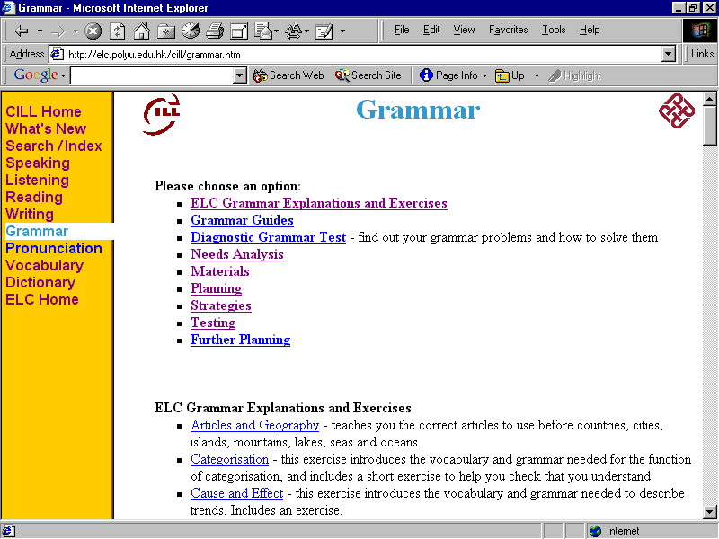
Figure 2: The Grammar page for the first test.

The second round of testing showed improvements for both groups in both task success rate and reductions in duration.

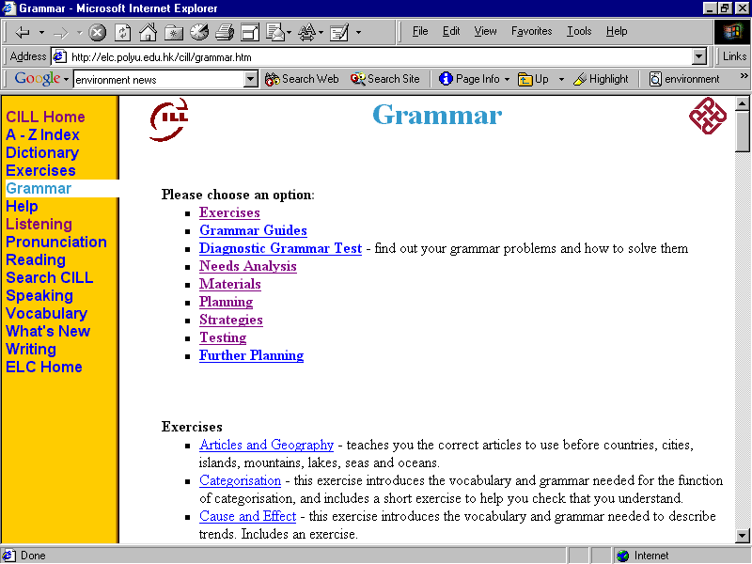
All the participants who had done the first round found the target URL, an improvement of 20% over the first round. Their mean time was 16 seconds, with a minimum of 12 seconds and a maximum of 22 seconds. The mean improvement in their times was 52 seconds, and the maximum improvement was 3 minutes 31 seconds. The standard deviation was 4 seconds, which was 1 minute 4 seconds shorter than in the first round of testing. This, when coupled with a shorter mean time is seen as an improvement, since a lower standard deviation implies a consistently shorter task time.
Figure 3: The Grammar page for the second test.

The participants who had not taken part in the first round all completed the task, again giving a 20% improvement. Their mean time was 53 seconds, with a range from 24 seconds to 3 minutes 41 seconds, giving an improvement of 15 seconds for the mean time. The minimum time increased from 20 to 24 seconds, while the maximum time improved by 2 seconds. The standard deviation was 1 minute 7 seconds, a one second decrease.

Figure 4: Question 1 Statistics

Question 2
“Find out how to pronounce ‘thorough’.”
The target URL was http://elc.polyu.edu.hk/cill/pronunci.htm
Timing stopped when the participant submitted the word ‘thorough’ to the text-to-speech engine by clicking the ‘Listen’ button.

In the first round of tests, 90% of participants submitted a word to the text-to-speech engine, with a number of participants mis-spelling the word, for example as ‘through’. This was ignored, as the test was of the ability of participants to find the text-to-speech engine, and ‘thorough’ was an arbitrary example word. Their mean time to find it was 36 seconds. The minimum was 16 seconds and the maximum was 1 minute 3 seconds, giving a range of 47 seconds. The standard deviation was 15 seconds.
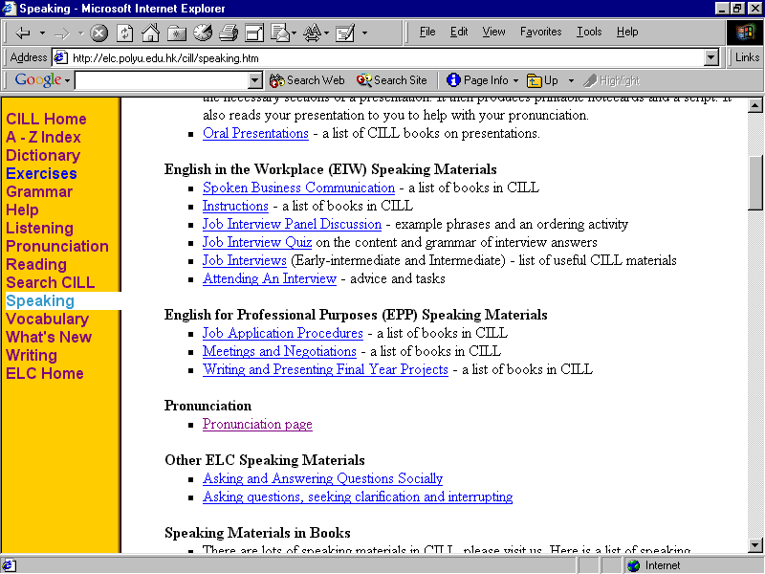
Two participants looked on the Speaking page, and so a link to the Pronunciation page was added to the speaking page, as shown in Figure 5.
Figure 5: Link to the Pronunciation page on the Speaking page.
The second round of testing showed improvements for both groups in both task success rate and reductions in duration, despite the fact that none of them looked on the Speaking page.

The 5 participants who had done the first round all completed the task, as they had in the first round. This was a 10% improvement compared to all the participants in the first round. The mean time to find it was 18 seconds, the minimum was 12 seconds and the maximum 24, an improvement of 26, 14 and 49 seconds respectively. The standard deviation decreased by 14 seconds.

Improvements in participant performance for tasks where little had changed on the target URL pages could be attributable to changes in the menu bar on the left side of each page, especially the home page, with its links now being mainly in alphabetical order, and thus possibly easier to find.
Figure 6: Question 2 Statistics
The participants who had not taken part in the first round all completed the task, again giving a 10% improvement, as compared to the participants in the first round of testing. Their mean time was 26 seconds, with a range from 12 to 51 seconds, giving improvements of 10, 4 and 12 seconds respectively. The standard deviation decreased by 2 seconds.

Question 3
“Find a page where you can learn vocabulary about the news.”
The target URL was http://www.bbc.co.uk/worldservice/learningenglish/news/index.shtml via http://elc.polyu.edu.hk/cill/vocabula.htm
Timing stopped when the participant arrived at the target URL.

In the first round of testing, all the participants found the target URL. Their mean time to find it was 1 minute and 42 seconds. The minimum was 16 seconds and the maximum was 5 minutes 49 seconds, giving a range of 5 minutes 33 seconds. The standard deviation was 1 minute and 56 seconds.

A spelling mistake was found in the link, where ‘world’ had been spelled as ‘word’. This was rectified before the second test.
Figure 7: Question 3 Statistics

The second round of testing showed improvements for both groups in reductions in duration.

The participants who had done the first round again all completed the task. The mean time to find it was 21 seconds, an improvement of 1 minute, 11 seconds for these participants. The minimum was 9 seconds and the maximum 38, an improvement of 9 and 2 minutes 43 seconds respectively, although one participant took 4 seconds longer. The standard deviation decreased by 1 minute 7 seconds.

The participants who had not taken part in the first round also all completed the task. Their mean time was 25 seconds, with a range from 8 to 56 seconds, giving improvements of 1 minute 16 seconds, 8 seconds and 4 minutes 45 seconds respectively. The standard deviation decreased by 1 minute and 39 seconds.

Question 4
Find a page where you can learn English by listening to pop music.
The target URL was http://www.bbc.co.uk/worldservice/learningenglish/music/index.shtml via http://elc.polyu.edu.hk/cill/listenin.htm
Timing stopped when the participant arrived at the target URL.

In the first round of testing, 90% of participants found the target URL. Their mean time to find it was 46 seconds. The minimum was 20 seconds and the maximum was 1 minute 39 seconds, giving a range of 1 minutes 19 seconds. The standard deviation was 32 seconds.

The word ‘pop’ was not in the text of the hyperlink on the Listening page in the first test, so when a participant searched for it there was no result. The word ‘pop’ was therefore added. For further discussion of the relationship between task wording and task time and success, see the Discussion section below.

The second round of testing showed improvements for both groups in both task success rate and reductions in duration in all except one case.

The participants who had done the first round again all completed the task. This was a 10% improvement over all the participants from the first round. The mean time to find it was 15 seconds, an improvement of 37 seconds for these participants. The minimum was 13 seconds and the maximum 17, an improvement of 10 seconds and 1 minute 22 seconds respectively. The standard deviation decreased by 36 seconds for these participants.

The participants who had not taken part in the first round all completed the task, again giving a 10% improvement.
Figure 8: Question 4 Statistics.

Their mean time was 34 seconds, with a range from 11 seconds to 2 minutes 42 seconds, giving improvements of 12, and 9 seconds respectively, but an increase in the maximum time of 1 minute and 43 seconds. This was caused by a participant exploring radio station sites before finding the target URL. The link to the radio stations sites preceded the target URL link in the list on the listening page.

Question 5
“Find a page with some common job interview questions and advice and an exercise about how to answer them.”
The target URL was http://elc.polyu.edu.hk/CILL/exercises/jobinterviewquestions.htm
Timing stopped when the participant arrived at the target URL.

In the first round of testing 80% of participants found the target URL. Their mean time to find it was 2 minutes and 40 seconds. The minimum was 39 seconds and the maximum was 5 minutes 41 seconds, giving a range of 5 minutes 2 seconds. The standard deviation was 1 minute and 59 seconds.

Participants’ problems with this task were caused by a number of factors. Firstly, the target URL was not linked to on the Speaking page, and many participants assumed that this was how it was categorised. A link was added for the second test.

Secondly, on the Index page, the target URL was indexed under ‘J’ for ‘Job’, rather than under ‘I’ for ‘Interviews’ where a number of candidates looked for it. A link was added under ‘I’.

Thirdly, there was a link to another web site giving information about interviews, which some participants followed. That site had re-organised its pages, so the link was broken. Although the site had been free when it was first linked to from the CILL site, it is now a site for which users need to pay. Therefore this link was deleted before the second test.

Finally, some participants used the site search to look for the target URL. The target URL sometimes appeared at the top of the results and sometimes in the top three. However, the CILL site uses Google’s university search, and the results do not show the meta tag information contained on the page, but instead show the words around the search term found in the text of the page, as shown in Figure 9. These words did not match wording of the task, and so participants did not click on the link.

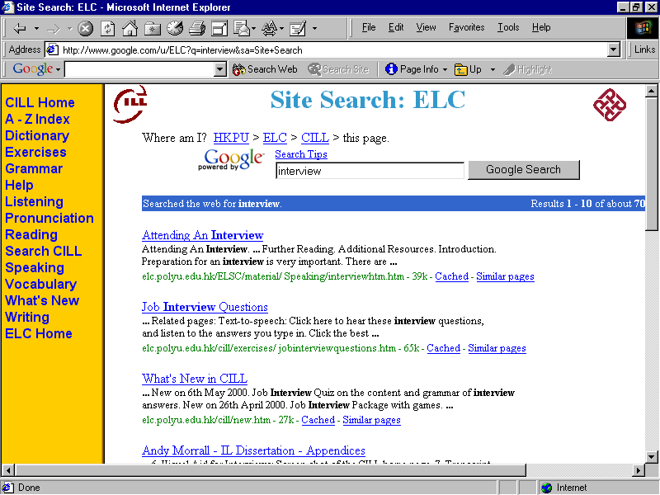
This problem was addressed by changing the wording closest to the top of the page containing the word ‘interview’ to text which gives a better description of the function of the site. However, as Google’s university search index of the site is only updated once a month, this change had no effect before the second test.
Figure 9: Site search engine results for ‘Interview’.

Some participants choose the top link in the search results seen in Figure 9, as it seemed most relevant. As the criteria which Google uses in its page ranking are secret, it is not known how to change the target URL page contents so that it would get a higher rating.

The second round of testing showed reductions in duration for both groups. However, although the group who had done the tasks before achieved a 100% success rate, an improvement of 40% for them, only 75% of the group who had not done the tasks before succeeded in this task. According to the participants, this was because the wording of the question was more similar to the wording of a different link, one that also led to advice about job interview questions. This was also the page that come out at the top of the search engine links for ‘interview’, as shown in Figure 9 above. The participants who failed on this task reached this page and assumed that they had found the target URL. Thus although the test target URL was not found, resulting in a reduction in task success for this question, this does not seem to be a serious problem with the usability of the site, as the content of the two pages is similar, and so students would probably find the information they need for job interviews.
Figure 10: Question 5 Statistics.
The participants who had done the first round all completed the task, a 40% improvement for them. The mean time to find it was 1 minute 5 seconds, an improvement of 1 minute 58 seconds for these participants. The minimum was 29 seconds and the maximum 2 minutes 4 seconds, an improvement of 11 seconds and 1 minute 55 seconds respectively. The standard deviation decreased by 1 minute 29 seconds.

Only 75% of the participants who had not taken part in the first round completed the task, giving a 5% reduction. Of those who completed the task successfully, the mean time was 49 seconds, with a range from 20 seconds to 1 minute 11 seconds, giving improvements of 1 minute 50 seconds, 19 seconds and 4 minutes 30 seconds respectively. The standard deviation decreased by 1 minute 37 seconds.

After the second round of testing was complete, the word ‘advice’ was added to the links to the target URL, to better reflect the contents of the page.

Question 6
“Look up the meaning of the word ‘discharge’.”
The target URL was http://elc.polyu.edu.hk/cill/dictiona.htm
Timing stopped when the participant submitted the word ‘discharge’ to an online dictionary by clicking the ‘Look Up’ button on the target URL page.

In Test 1, all of the participants found the target URL. Their mean time to find it was 36 seconds. The minimum was 10 seconds and the maximum was 3 minutes 4 seconds, giving a range of 2 minutes 54 seconds. The standard deviation was 52 seconds.

Given the high success rate and low task durations, no changes were made to the target URL relating to this task. However, the link ‘Dictionary’ had been moved closer to the top of the menu bar on the left side of each page.
Figure 11: Question 6 Statistics.

The second round of testing showed improvements for both reductions in duration.

The participants who had done the first round all completed the task successfully. The mean time to complete it was 17 seconds, the same as for the first round of testing. The minimum was 12 seconds and the maximum 25, a reduction of 2 seconds and an improvement of 4 seconds respectively. The standard deviation decreased by 3 seconds.

The participants who had not taken part in the first round also all completed the task successfully. Their mean time was 15 seconds, with a range from 11 to 22 seconds, giving improvements of 21 seconds for the mean, a reduction of 1 second for the minimum, and an improvement of 2 minutes 42 seconds for the maximum. The standard deviation decreased by 48 seconds.

Question 7
“Using a CILL web site page, make a correct bibliographic reference for a book with the following details:
Title: Better Academic English
Author: Smith, John
Year of publication: 2002
Place of publication: Hong Kong.
Publisher: Hong Kong Polytechnic University Press.”

The target URL was http://elc.polyu.edu.hk/cill/referenceMachinebooks.htm Timing stopped when the participant clicked the ‘Create Reference’ button at the bottom of the form that creates the reference on the target URL page. Some participants made spelling and copying errors, and others confused author’s family and other names. These problems were ignored for the purposes of timing and the success of the task, but the usability problems were recorded and addressed in the inter-test changes to the site.

In the first round of testing, 70% of participants completed the task. Their mean time was 3 minute and 35 seconds. The minimum was 1 minute 24 seconds and the maximum was 5 minutes 54 seconds, giving a range of 4 minutes 30 seconds. The standard deviation was 1 minute and 37 seconds.

This task generally took longer to complete because it involved not only finding the right page, but also filling in a form on that page, which depended partly on the participants’ typing speed.

This was the task that the participants had most difficulty with. There were a number of reasons for this.

Firstly, navigation to the target page was complicated by a number of factors.

The Index lacked a link entitled ‘Bibliographic References’. This was added prior to the second round of testing.

Also, the skills of referencing are taught on the English for Academic Purposes course, but the main page for this course did not have a link to bibliographic references for books. This was added.

In addition, the Reference Machine page included a list of referencing-related pages that is imported from another file, which contained a link referring to that same page. Thus some users clicked it and the same page loaded again. This link was removed before the second test.

On the Writing page, which many participants used on their path to the target URL, there was only a link to one referencing page, rather than to a list of all of the relevant pages. This list was added before the second test.

Secondly, the target URL page had a number of usability problems.

One of these was that while the form that generates the reference asked for the author’s initials, the task gave the name ‘John’, and no second initial. The form was
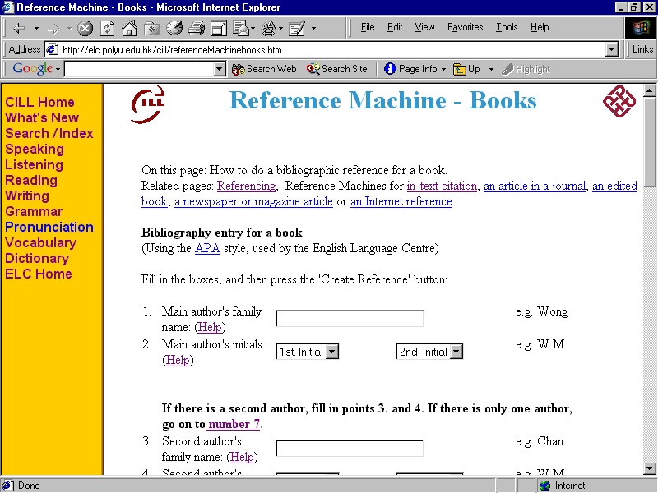
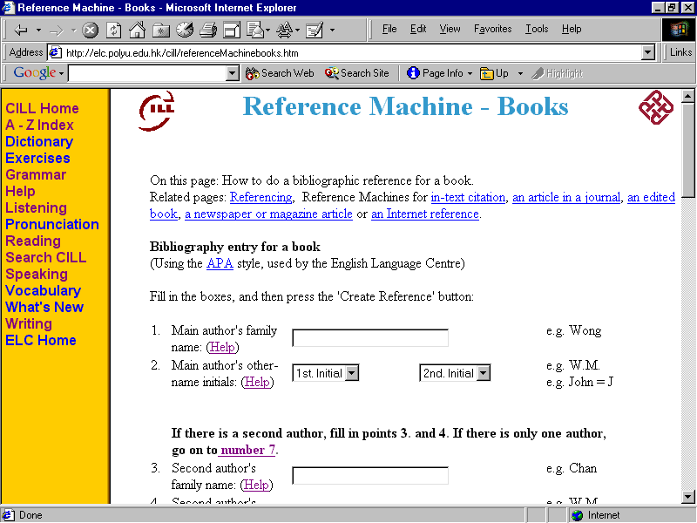
Figure 12: Changes made to the page ‘Reference Machine – Books’.

modified to emphasise that only the initials of the author’s other names are required, (see Figure 12).

In general, although the page contains detailed instructions, advice and examples of how to fill in the form, participants did not read them. For example, some participants filled in the author’s full name in the box marked “1) Main author's family name:”, and missed out the author’s initials.

It would not be possible to have the browser alert the user to this, as initials are not always necessary in references, for example when a book is published by an organisation, and the author’s name is not made available.

The second round of testing showed improvements for the group who had taken the test before in both task success rate and reductions in duration, but only for the success rate for the group who had not done the test before.

In the second test it was noticed that when a participant chose the initial ‘J’, and then scrolled down the page to the next form box using the wheel on the mouse, the browser changed the selected initial. However, if the scroll bar was used, the initial remained the same. In a post-study site design iteration it may be possible to use JavaScript to record the user’s click and ignore any future scrolling with the mouse wheel, and thus solve this problem.

It may also be possible to check the author’s name box to see if it contains a comma, and then delete the comma and any subsequent characters. The first of these subsequent characters could automatically by used as the author’s initial.

As before, of the participants who had done the first round all but one completed the task. The participant who did not complete the task had also not completed it in the first round, as she had been prompted how to navigate to the right page. In the second round of testing she also did not find the target URL.
Figure 13: Question 7 Statistics.

For this group the mean time to complete the task was 2 minutes 18 seconds, an improvement of 2 minutes 19 seconds for these participants. The minimum was 1 minute 3 seconds and the maximum 4 minutes 4 seconds, an improvement of 21 seconds and 1 minute 50 seconds respectively. The standard deviation decreased by 3 minutes 4 seconds.

Six out of eight of the participants who had not taken part in the first round completed the task, giving a 5% improvement. Their mean time was 3 minutes 47 seconds, with a range from 2 minutes 44 seconds to 4 minutes 27 seconds, giving an increase of 12 seconds for the mean time, and 1 minute 20 seconds for the minimum time. The maximum time deceased by 3 minutes 27 seconds. The standard deviation decreased by 51 seconds.

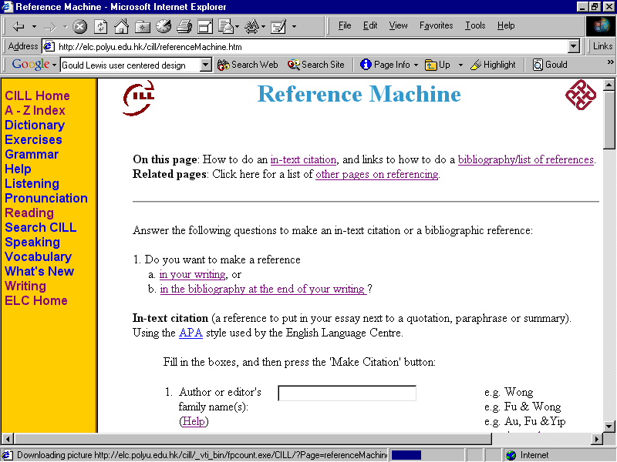
Six of these participants found the Reference Machine page, but then started to fill in the form to make an in-text citation, rather than going to the Reference Machine – Books page (the target URL) and writing a bibliographic reference. Only when they discovered that there was information given in the task that was not required by the form did they realise that they were doing the wrong type of reference. This was despite there being words on the page stating that this was a form for creating an in-test citation, and there being links to pages for bibliographic referencing.

Figure 14: Screen shot of the Reference Machine Page, with instructions highlighted.
The participants tended to see the form and immediately start filling in the first box, without reading the instructions.

As a result of these observations, the Reference Machine page was modified to be a page that re-directs users according to whether they want to make an in-text citation or a bibliographic reference. The part about constructing an in-text citation was moved to a new page.
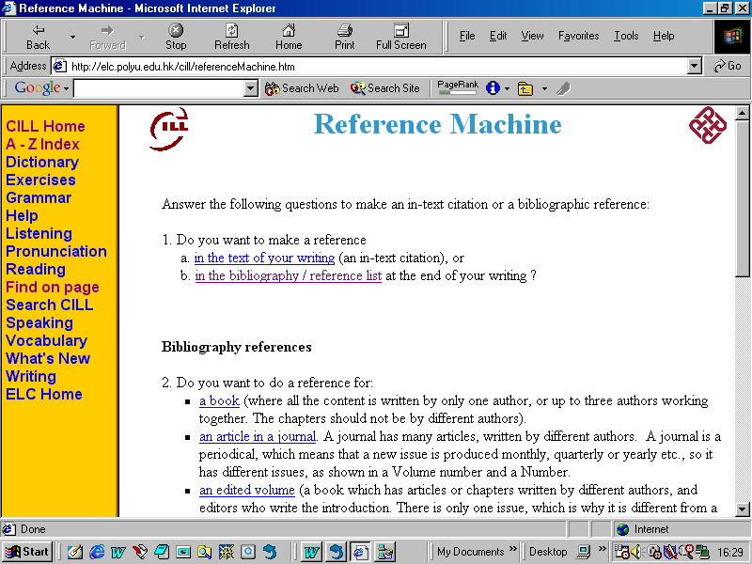
Figure 15: The Reference Machine page as a route to in-text citations or bibliographical referencing.

Two of the participants were new students who did not know anything about references because they had not taken the English for Academic Purposes course that covers this aspect of writing. Both failed to complete Task 7 successfully, in that both failed to find the target URL, and both had problems filling in the form due to a lack of ability to distinguish between family and other names. Neither accessed the ‘Help’ links that would have helped them with this issue.

It may be possible to program the page to parse an author’s full name correctly, but this would be complicated due to the different name conventions used internationally.

Question 8
“Find a page which helps you to write a job application letter.”
The target URL was http://elc.polyu.edu.hk/cill/jal.htm
Timing stopped when the participant arrived at the target URL.

In the first round of testing, all of the participants found the target URL. Their mean time to find it was 22 seconds. The minimum was 10 seconds and the maximum was 54 seconds, giving a range of 44 seconds. The standard deviation was 13 seconds.

One participant thought that a link to a page on job application letters would be included in the ‘Business Letters, Memos and E-mails’ section of the EIW page, when it was originally in the ‘Accessing the Workplace’ section, in accordance with the contents of the EIW course book. A link was added before the second test.

The link to the target URL was also moved closer to the top of the Writing page because another link was moved down the page due to its more general nature, and it not pointing to a page on the CILL site. In general links to pages on the CILL or ELC sites are given higher in lists of resources and exercises because they tend to suffer less from ‘linkrot’, which is links becoming broken because the referenced page has been deleted, moved, or put behind a password.

The second round of testing showed improvements for both groups in reductions in duration.
Figure 16: Question 8 Statistics.

The participants who had done the first round all completed the task, maintaining the 100% task success rate. The mean time to find it was 19 seconds, an improvement of 3 seconds for these participants. The minimum was 10 seconds and the maximum 52, an improvement of 0 and 2 seconds respectively. The standard deviation remained unchanged.

The participants who had not taken part in the first round all completed the task, again maintaining the 100% task success rate. Their mean time was 19 seconds, with a range from 9 to 48 seconds, giving improvements of 3, 1 and 6 seconds respectively. The standard deviation increased by 1 second.

Question 9
“Find a page where you can read about e-mail pen-pals you can write to.”
The target URL was http://www.bestmall.com/penpals/view.htm via http://elc.polyu.edu.hk/cill/writing.htm#Writing to E-mail Pen-pals
Timing stopped when the participant arrived at the target URL.

In the first round of testing all of the participants found the target URL. Their mean time to find it was 1 minute and 18 seconds. The minimum was 16 seconds and the maximum was 4 minutes 20 seconds, giving a range of 4 minutes 4 seconds. The standard deviation was 1 minute and 14 seconds.

In order to make this task easier, a link was added to the Index page under ‘E’, and another link was added to the e-mail section of the home page, where one participant looked for it.

In the second test one participant, who had successfully found the link in the first test, could not find it, because he said he did not understand the word ‘pals’. In the post-test design iteration, ‘pen-friends’ was therefore added.
Figure 17: Question 9 Statistics.
The second round of testing showed reductions in duration for both groups.

All but one of the participants who had done the first round completed the task, a reduction of 20%. The mean time to find the target URL was 23 seconds, an improvement of 11 seconds for these participants. The minimum was 10 seconds and the maximum 40, an improvement of 6 seconds and 2 minutes 40 seconds respectively. The standard deviation decreased by 60 seconds.
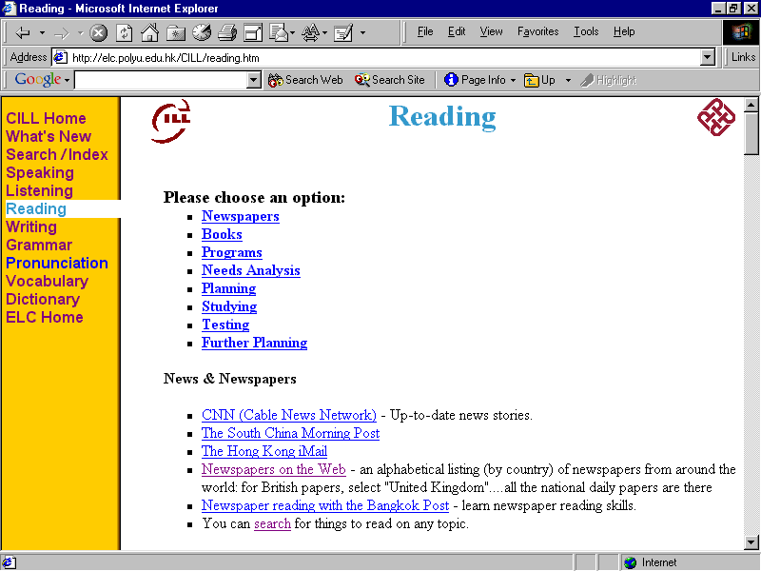
Figure 18: The Reading page in the first round of testing.
The participants who had not taken part in the first round all completed the successfully. Their mean time was 54 seconds, with a range from 9 seconds to 1 minute 26 seconds, giving improvements of 24 seconds, 7 seconds and 2 minutes 54 seconds respectively. The standard deviation decreased by 45 seconds.

Question 10
“Find a page that helps you improve your newspaper reading skills.”
The target URL was http://www.bangkokpost.net/education/stutips.htm via http://elc.polyu.edu.hk/CILL/reading.htm#Newspapers
Timing stopped when the participant arrived at the target URL.

In the first round of testing, 90% of participants found the target URL. Their mean time to find it was 58 seconds. The minimum was 18 seconds and the maximum was 2 minutes 1 second, giving a range of 1 minute 43 seconds. The standard deviation was 38 seconds.
Figure 19: Question 10 Statistics.
Participants found the link text confusing, as it was in a list of newspapers, and included the name of the newspaper that hosts the newspaper reading skills pages. The words ‘reading skills’ were outside the blue underlined link text, as shown in Figure 20.

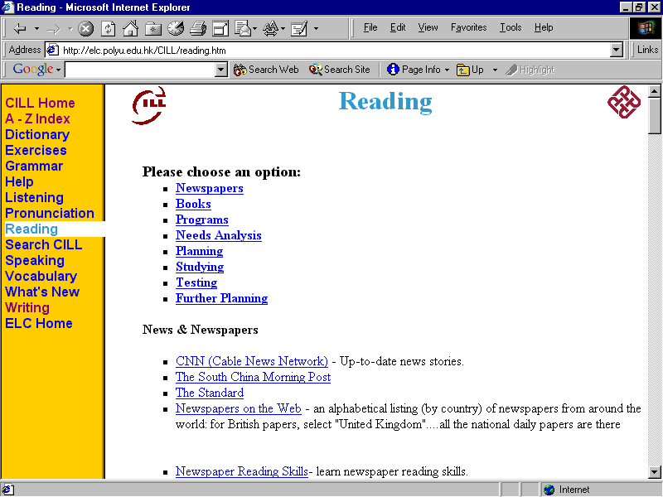
For the second test the name of the newspaper was removed, and the link text changed. In addition some white space was added between the list of newspapers and this link in order to reflect the difference between the language learning possibilities.
Figure 20: The links to the newspaper reading skills site in the second test.

The second round of testing showed improvements for both groups in both task success rate and reductions in duration.
The participants who had done the first round again all completed the task. This was a 10% improvement over all the participants from the first round.

The mean time to find it was 16 seconds, an improvement of 42 seconds for these participants. The minimum was 8 seconds and the maximum 30, an improvement of 10 and 81 seconds respectively. The standard deviation decreased by 30 seconds.

The participants who had not taken part in the first round all completed the task, again giving a 10% improvement. Their mean time was 18 seconds, with a range from 9 to 35 seconds, giving improvements of 40, 9 and 1 minute 26 seconds respectively. The standard deviation decreased by 31 seconds.

4.6 Test 1 Totals
In the first round of tests, the minimum test time on task was 5 minutes and 14 seconds and the maximum 34 minutes, which included time spent on tasks that were failed. The lowest number of successfully completed tasks was 6 and the highest was 10. The fastest user completed all the tasks successfully, and the slowest completed 6.

The following table summarises the improvements in task success rate and reductions in task completion time between the first and second round of testing.
Table 8: Summary of Improvements
Task Number | Task Success |  |  |  | Mean Task Duration
Task Number | Improvement or remained at maximum |  | Improvement in percent |  | Improvement or remained the same |  | Improvement in seconds
Task Number | Re-test group | New group | Re-test group | New group | Re-test group | New group | Re-test group | New group
1. | ✓ | ✓ | 20% | 20% | ✓ | ✓ | 52 | 15
2. | ✓ | ✓ | 0% | 10% | ✓ | ✓ | 26 | 10
3. | ✓ | ✓ | 0% | 0% | ✓ | ✓ | 71 | 76
4. | ✓ | ✓ | 0% | 10% | ✓ | ✓ | 37 | 12
5. | ✓ | ✗ | 40% | -5% | ✓ | ✓ | 118 | 111
6. | ✓ | ✓ | 0% | 0% | ✓ | ✓ | 0 | 21
7. | ✓ | ✓ | 0% | 5% | ✓ | ✗ | 139 | -12
8. | ✓ | ✓ | 0% | 0% | ✓ | ✓ | 3 | 3
9. | ✗ | ✓ | -20% | 0% | ✓ | ✓ | 11 | 24
10. | ✓ | ✓ | 0% | 10% | ✓ | ✓ | 42 | 40
Total / Mean | Total = 9 | Total =  9 | Mean =  4% | Mean =  5% | Total =  10 | Total =  9 | Mean = 50 | Mean =  30

4.7 The Post-test Questionnaire
In the post-test questionnaire, questions 6 to 8 asked participants to rate their agreement with three statements on a range of agreement: ‘Strongly Agree’, ‘Agree’, ‘Neither Agree or Disagree’, ‘Disagree’ or ‘Strongly Disagree’. In both rounds of testing the mode for Question 6, ‘It was very easy to learn how to use this site.’ was ‘Agree’. The mode for Question 7, ‘Using this site was a very frustrating experience.’ was ‘Strongly Disagree’ in the first round, and ‘Disagree’ in the second, possibly indicating that the site had become more frustrating to use. The mode for Question 8, ‘This site is very pleasant to work on.’ was ‘Agree’ in both rounds.

However, these findings should be regarded with caution, as the tester was sitting next to the participants when they filled out the questionnaires. Most participants knew, and some asked, if the tester was also the author of the site, and under such direct questioning this had to be admitted to. This probably affected the results. For example, in the first round of testing, participant 1, when answering the question about frustration, was hovering his pen above the ‘Agree’ option, before glancing at the tester and filling in the ‘Neither Agree or Disagree’ option.

4.8 Summary of the Findings as Related to the Research Questions

The main research question was to investigate whether ‘Discount Usability Testing’ is effective in improving the usability of a site.

This overall question was divided into three. The first research question asked whether the improvements to the site made during the usability study result in improvements in test participants’ success rate in completing tasks on the CILL site. As can be seen from Table 8 above, there was a 4% improvement for the group who did both rounds of test, and a 5% increase in the task success rate of the second round participants over the first round participants.

The second research question asked whether the improvements to the site made during the usability study result in participants being able to carry out these tasks in a shorter time. As can be seen from Table 8 above, there was a mean improvement per task of 50 seconds for the group who took both rounds of tests, and a mean decrease in duration per task of 30 seconds for the second round of tests versus the first round.

The final research question asked whether the participants say that they believe that the site is easier to use. Of the five participants who took part in both round one and round two of the tests, one strongly agreed, one agreed and three neither agreed or disagreed.

Therefore, based on these three measurement criteria, ‘Discount Usability Testing’ was effective in improving the usability of the CILL site.

5 Discussion

5.1 Changes to the Site
As a result of this study a large number of changes were made to the site, and most of them resulted in improvements in usability.

As mentioned above, three modifications were made to the CILL web site as a result of the initial questionnaire.

Firstly a list of exercises was added to the grammar page. Twelve participants used this during the tests. Secondly, the item ‘Dictionary’ was added to the left-side menu on each page. Sixteen participants used this link. Finally, a link to the list of all exercises included in the index. This link was not used by the test participants.

As a result of the first round of testing 19 changes were made to the site. Changes were made for every task except Task 6, on finding the meaning of the word “discharge”, which had been completed successfully by all participants. However, performance on this task may have benefited from the movement of the ‘Dictionary’ link to a higher place in the left menu on all pages. As discussed in the previous chapter, observation during round two of the tests indicates that these changes may have resulted in improvements in both task success rate and reductions in time to successfully complete tasks.

As a result of the second round of testing, usability problems were found with Task 5 on job interview questions, Task 7 on writing references and Task 9 on finding e-mail pen-pals.

5.2 Reliability

5.2.1 Low sample size
The total number of participants in the study was 18. Ten of these took part in the first round of testing. In the second round of testing 5 participants took the test again, and 8 participants took part in the second round only. Rubin (1994, p.283) recommends a sample size of “at least 10 to 12 participants per condition before considering the use of inferential statistics”. At such low sample sizes, it is difficult to rely on the quantitative results of this study. However, they are interesting to note.

One consequence of the low sample size is the disproportionate effect of out-liers. One of the participants in the first round of testing completed six out of ten tasks correctly in a total time of 34 minutes, 49 seconds. Without this participant, the mean task success rate would have been 95% rather than 91%. This 95% is the same as the task success rate for the second round of testing for participants who had done the first round, and therefore there would have been no improvement. Unfortunately this participant, although asked, did not volunteer to take part in the second round. This was possibly due to embarrassment about his performance in the first round, a feeling that may be common among such participants, resulting in difficulties in recruiting them to take part in comparative tests.

However, even with this participant’s results removed from the calculations, there were still reductions in mean task duration, from 14 minutes 28 seconds in the first round, to 5 minutes 18 seconds for the group who had done the test before and 7 minutes 35 seconds for the group who hadn’t.

An advantage of ‘out-lier’ participants is that observing them provides a large number of ideas for improvements to the usability of the site, ideas that might not appear with other users. If such participants can also take part in the second round of testing it may be useful to note whether the re-design has improved the site for such users.

To check the reliability of the improvement figures, the confidence intervals for the mean time to complete test tasks successfully was calculated for an alpha of 0.05 (95%) and 0.2 (80%), using the functions of Microsoft Excel 97.

Table 9: Confidence that Task Performance Improved
 | First Round | Second Round  (Re-test Group) | Second Round (New Group) | Second Round (New Group)
alpha | 0.05 (95%) | 0.05 (95%) | 0.05 (95%) | 0.2 (80%)
Standard  Deviation | 255 seconds | 135 seconds | 191 seconds | 191 seconds
Participants | 10 | 5 | 8 | 8
Confidence | 158 seconds | 118 seconds | 132 seconds | 86 seconds
Mean time | 701 seconds | 318 seconds | 455 seconds | 455 seconds
Mean -/+ confidence | 543 to 859 | 200 to 436 | 323 to 587 | 369 to 541

The table shows that statistically there is 95% degree of confidence that the minimum mean duration for the first round of testing was 543 seconds, or 9 minutes 3 seconds. There is a 95% confidence that the maximum mean duration on the second round of testing for the group who had done the first round was 436 seconds, or 7 minutes 16 seconds. Therefore there is a 95% degree of confidence that they improved their mean time to complete the tasks that they completed successfully.

However, for the group who had not done the first round of testing, there is less confidence in their improvement over the participants in the first round. It is only at the 80% confidence level that the minimum mean duration for the first round of testing was bettered by their maximum-possible mean duration.

The mean times are times for participants to complete a task successfully, rather than times to complete the whole test. Times for not completing a task are not used because there was no consistent criteria for when to stop timing because a participant had failed a task. For example, some participants gave up, and went on to the next task. Others appeared lost, and showed no signs of being able to complete the task, so to prevent further frustration being felt by the participant, the tester stopped the task. Sometimes, in order to further test the usability of a task, the tester guided the participant, for example as in Question 7, in which some participants were guided to the target URL, their performance in filling in the form was observed, and important usability problems discovered.

As neither Nielsen or Rubin give specific suggestions on how to deal with this problem of how to statistically handle task durations for failed tasks, a number of options were considered.

For practical and ethical reasons, it was not seen as an option to force participants to continue for an infinite amount of time or until they gave up on a task in frustration. Nielsen (1993, p.183) suggests that “the experimenter should not let a user struggle endlessly with a task if the user is clearly bogged down and getting desperate.” Testers should use their judgement to balance the need to observe participant behaviour that could prompt usability improvements with maintaining participants’ goodwill.

The first option considered was to use a time when the participant stopped working on a task, regardless of the reason. However, this was rejected as the reasons for stopping varied. Such reasons included, for example, going to a page that was not the target URL and assuming that the task was complete, or lack of understanding of the task requirements, especially for Task 7 on referencing, if the participants had no experience of referencing.

A second option was to give artificial times, such as 10 minutes, the longest time to successfully complete the tasks or the mean time to successfully complete the task. However, all these seemed arbitrary and would distort the results.

Finally it was decided to ignore failed or incomplete tasks in calculations of mean task times and total test durations.

5.2.2 Timing Method
The tests were timed with the stop-watch function of a program called ‘Big Clock’ on a Palm IIIc personal digital assistant. Such timing is only accurate to within a second or two. It would be more accurate to use another method, such as the counter on a video recording the test. However, this was not done as it was felt that videoing would add to the stress of the test participants.

5.3 Validity

5.3.1 Task Wording
Some participants commented that the wording of some tasks made the task straightforward, but caused problems with other tasks. For example, Task 3, “Find a page where you can learn vocabulary about the news” was completed correctly by all participants in all tests, as most of them went to the Vocabulary page, and looked for the word ‘news’. However, the word ‘advice’ in Question 5, “Find a page with some common job interview questions and advice and an exercise about how to answer them”, caused some difficulty, with one participant explaining that he had selected a different link because the word ‘advice’ was not in the link or the associated text of the link to the target URL. A third example is that of a participant in round two of the tests, who said that he did not understand ‘pen-pals’ as meaning ‘pen-friends’.

Thus to improve the usability statistics of a site, the wording of a task could just be changed to more closely reflect the wording of the links on the site, or vice-versa. However, there is no guarantee that the task wording is following Nielsen’s (1993, p.123) heuristic of ‘speaking the user’s language, especially as the site is for second language users, who may have different interpretations of the meaning of the tasks and links on the site to those intended by the designer. It might also be justifiable to put links to the target URLs in a list or menu on the home page, as the pre-test questionnaire showed that these are the most common uses for the site! However, this was not done as users may use the site in other ways, and it might interfere with their mental model of the site structure. Nonetheless, a link to a CILL site tour was added to the home page, and the tour consists of pages on the test task areas.

5.3.2 Task Authenticity
One possible method of overcoming the task wording problem might be to use a more authentic type of task. For example, when giving feedback on students’ writing, ELC staff sometimes refer the students to materials on the Internet. It would be possible to create a task based on a text containing authentic examples of errors in students’ writing, in which test participants were asked to correct highlighted errors using the information on the site being studied. One effect of this task type would be to test the effectiveness of the instructional materials on the site, in addition to the usability issues investigated in this study.

However, there might also be a number of problems. Firstly, the participants might understand the error and correct it without use of the site. Secondly, as the task would be more complex it might take much longer to complete. Thirdly, it might be difficult to time individual tasks, as participants might browse the site and do the tasks out of order, or do more than one task simultaneously, although this might reflect the way users might use the site when not being tested. However, using only task success and observation, and not comparing individual task times, might be a practical and successful methodology for demonstrating changes in site usability.

Finally, such a task might not reflect the way in which users actually use the site. For example, it would be difficult to integrate the pronunciation task that was included because users in this study said they used the CILL site for pronunciation work. However, there could be an argument that this would be a valid test if this was the way in which CILL staff designed and intended the site to be used.

This is an area in which further study could be done.
5.3.3 Participants’ Reading of the Tasks
It was noticed that different participants had different styles when reading the tasks. Some seemed to barely glance at the task as it was shown to them on paper, and others read them more carefully. Two participants in particular, both teachers, one a native speaker of English and the other of Chinese, read the tasks out loud. The Chinese-speaker completed all the tasks successfully in both the first and second rounds, with better-than-average times in both tests. The English speaker, who only took part in round two, succeeded in 9 out of 10 tasks, also in an above-average time.

In future tests it might be informative to ask one group of users to read the task instructions aloud, and another group to read them silently, and compare the results of the two groups. In addition, another group could have the task read to them by the tester, and then be shown it.
5.3.4 Representativeness of the Participants

Nielsen, in his section on usability test validity, warns against using unrepresentative participants (1993, p.169). It is possible that the test participants did not represent the users of the CILL site, in that CILL has thousands of student members and there are only 60 ELC staff, but ELC staff made up 55% of the test participants. This was done because of the low number of student volunteers.

Analysing the test results for the students only gives the following table, which indicates improvements in task success and reductions in task duration for students in the second round of testing.

Table 10: Summary of Improvements for Students
Task Number | Task Success |  |  |  | Mean Task Duration
Task Number | Improvement or remained at maximum |  | Improvement in percent |  | Improvement or remained the same |  | Improvement in seconds
Task Number | Re-test group | New group | Re-test group | New group | Re-test group | New group | Re-test group | New group
1. | ✓ | ✓ | 25% | 25% | ✓ | ✓ | 112 | 79
2. | ✓ | ✓ | 25% | 25% | ✓ | ✓ | 24 | 5
3. | ✓ | ✓ | 0% | 0% | ✓ | ✓ | 35 | 75
4. | ✓ | ✓ | 25% | 25% | ✓ | ✓ | 46 | 30
5. | ✓ | ✓ | 25% | 25% | ✓ | ✓ | 185 | 130
6. | ✓ | ✓ | 0% | 0% | ✓ | ✓ | 14 | 44
7. | ✓ | ✗ | 0% | -16% | ✓ | ✓ | 163 | 3
8. | ✓ | ✓ | 0% | 0% | ✓ | ✓ | 22 | 8
9. | ✗ | ✓ | -50% | 0% | ✓ | ✓ | 16 | 67
10. | ✓ | ✓ | 0% | 0% | ✓ | ✓ | 20 | 33
Total / Mean | Total = 9 | Total =  9 | Mean =  5% | Mean =  8.3% | Total =  10 | Total =  10 | Mean =  63 | Mean =  47

If the out-lier mentioned above, who is a student, is removed from these figures, there is still improvement in task success in 9 out 10 tasks for students who hadn’t done the test before, and the mean test completion time improved by 5 minutes and 53 seconds.
5.3.5 Participants’ Native Language
It is also possible that, as most CILL members are native speakers of Chinese, the results were affected by the increased number of native speakers of English who took part in the second round of testing. There were two in the first round, and in the second round, of the participants who had taken the test before there were none, and in the group who had not taken the test before there were five.

The following table summarises the improvements made by native speakers of Chinese (both students and teachers), of whom there were eleven, nine being native speakers of Cantonese, and two of Putonghua.
Table 11: Summary of Improvements for Native Speakers of Chinese
Task Number | Task Success |  |  |  | Mean Task Duration
Task Number | Improvement or remained at maximum |  | Improvement in percent |  | Improvement or remained the same |  | Improvement in seconds
Task Number | Re-test group | New group | Re-test group | New group | Re-test group | New group | Re-test group | New group
1. | ✓ | ✓ | 25% | 25% | ✓ | ✓ | 75 | 40
2. | ✓ | ✓ | 12.5% | 12.5% | ✓ | ✓ | 30 | 7
3. | ✓ | ✓ | 0% | 0% | ✓ | ✓ | 92 | 90
4. | ✓ | ✓ | 12.5% | 12.5% | ✓ | ✓ | 44 | 33
5. | ✓ | ✓ | 25% | 25% | ✓ | ✓ | 224 | 132
6. | ✓ | ✓ | 0% | 0% | ✓ | ✓ | 9 | 25
7. | ✓ | ✗ | 12.5% | -29% | ✓ | ✗ | 186 | -21
8. | ✓ | ✓ | 0% | 0% | ✓ | ✓ | 18 | 3
9. | ✗ | ✓ | -25% | 0% | ✓ | ✓ | 15 | 39
10. | ✓ | ✓ | 12.5% | 12.5% | ✓ | ✓ | 34 | 38
Total / Mean | Total = 9 | Total =  9 | Mean =  7.5% | Mean =  5.8% | Total =  10 | Total =  9 | Mean =  73 | Mean =  39
Removing the out-lier, who is a native speaker of Chinese, from these figures, does not remove all improvement. It reduces the mean improvement in success rate for the group who had not used the site before from 5.8% to 2%, and decreases the mean improvement in time spent on successfully answered tasks from 6 minutes 29 seconds to 5 minutes 58 seconds.

5.3.6 Measuring and the Effects of Participants’ Computer Skills
A wide range of computer skills were observed among the participants. For example, at least 2 participants did not know the use of the ‘Home’ button on the browser, and to get back to their home page they shut down the browser and re-started it.

All but one user scanned pages with their eyes to find links, a sometimes slow and error-prone strategy. The remaining user used the browser’s ‘Find’ or ‘Find on page’ function, and completed the first round test with a 90% task success rate, the missed question being Question 7 on referencing, which this participant had little experience of. The participant completed the 9 tasks, which were answered correctly in 7 minutes 22 seconds, compared to a mean time for all the first round participants of 11 minutes 41 seconds. This equates to a 60% shorter time. This participant was not a teacher and was a native speaker of Chinese.

Given the high number of users who scanned the page for information, and often overlooked relevant links, and given the efficiency with which the computer can scan a page for a word, a find function was added to the left menu bar of all pages.
Due to coding limitations, this only appears and works in Internet Explorer. Figure 21 shows this find function in action. Note that the word being searched for, 'CILL', is highlighted in the middle of the page.

The participants use of navigation and information-finding aids and functions such as the ‘Find’ function, the Site Search facility, the A-Z index and Site Maps was investigated by questionnaire and observation. However, the results were
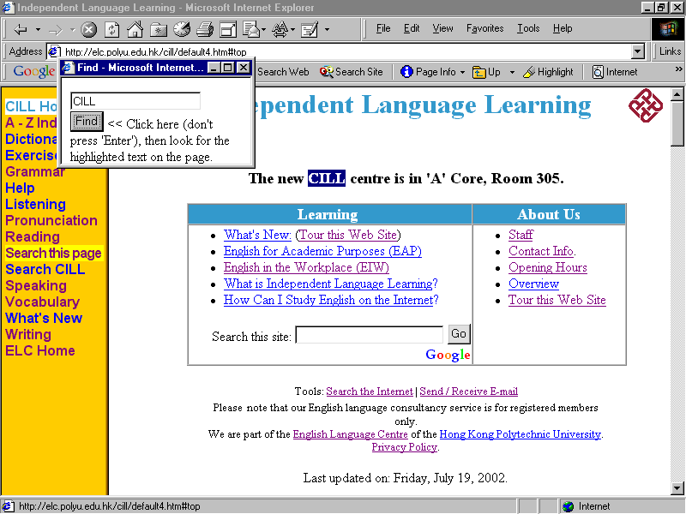
Figure 21: The Find Function.
inconclusive, as even with demonstration and explanation, many participants did not know what these were and could not accurately say how often they had used them.

Observation was also inconclusive, as participants always used link-following as their prime navigational strategy, and only used the Site Search and the A – Z Index when they failed to find something by link-following.

Therefore it was difficult to accurately measure participants’ computer skills, and therefore impossible to correlate them with task success rates or durations.

In addition, therefore, Nielsen’s properties of ‘learnability’ and ‘efficiency’, as discussed in the Literature Review, cannot be commented on in this study due to the difficulty in categorising participants as novices or experts. For example, from participants' questionnaire replies and actions it seems that a user can use the Internet for over 1,000 hours and still not know about the function of the browser’s home button.

Nielsen’s property of subjective ‘satisfaction’, which he suggests investigating by asking participants how frustrating they found the site, had modes of ‘Strongly Disagree’ (that using the site was frustrating) on the first round of tests, and ‘Disagree’ on the second round, indicating that satisfaction had decreased.

For future studies these problems could be tackled by using larger sample sizes, chosen at random, to give a set of participants with more representative levels of computer skills. A valid and reliable measure of Internet skills could be developed or taken from the literature, used with participants, and then relationships between task success and duration could be compared to these skills.

Pre-test training, as discussed by Nielsen (1993, p.177), in search skills was considered, but rejected as it would make test participants unrepresentative of the larger population of CILL site users, assuming that the small sample size group of participants are not unrepresentatively lacking in such skills.

When evaluating the severity and priority of usability problems, it was not found necessary to use severity ratings because all the usability problems discovered in the first round of testing could be addressed before the second round. This is, perhaps an advantage of a usability study of an Internet site rather than a computer program, as Internet pages tend to be less interdependent and thus easier to modify. However, on other sites, which might have a greater number or more severe usability problems, such problems might need rating and prioritising.

Finally, as Nielsen (1993, p.174) recommends, it is important to be consistent about what exactly “constitutes a user error or exactly when the user can be said to have completed a given test task”. For example, in Task 7 it was problematic to judge whether participants had completed the task due to variations in the correctness of the bibliography references they produced.

5.4 An Alternative to Testing in Rounds
In this research study there were two rounds of testing, separated by a re-design of some of the site. A disadvantage of this test structure is that known usability problems persist on the site until the round of testing is finished. As the site is available to users who are not taking part in the study during the test, these users are using a site with known but uncorrected usability problems. In addition, later test participants encounter usability problems that are already known from previous tests. These problems result in unnecessarily low rates of task success and longer task durations, and may also provoke greater feelings of frustration with the site and the tests.

A possible alternative to this structure that could be used in future research would be to make changes to the site after smaller numbers of tests, and possibly after each participant’s test. Instead of analysing the statistics for rounds of tests and comparing them, the analysis could look for trends in test performance, quantitatively in increasing task success rates and decreasing task durations, and qualitatively in decreasing frustration with the site and increasing subjective satisfaction with it. This approach is briefly alluded to by Rubin (1994, p.259), who discusses daily changes in the context of design prioritisation.

However, there are some potential disadvantages of this structure, which need further research in order to judge their severity. Firstly, a larger sample size might be necessary to decrease the effects on the overall trend of unusually good or bad individual performances on the tests. Secondly, a participant might have a unique or rare problem with a task, and the performance of other participants on this task may need to be observed before a decision can be made as to the severity of the problem and the need for a revision to the site.
One way to handle these disadvantages might be to maintain a list of usability problems and their severity, and increase the severity rating of a problem if it re-occurs, in a way similar to Nielsen’s (1993, p.104) suggestion discussed in the Literature Review. Thus problems could be re-prioritised after each test, and the highest-priority ones addressed before the next test.

Further research could therefore examine these possibilities and suggest the best size of a group of participants to test before changes are made to a site.

6 Conclusions

6.1 Results of the Study
The usability study was a success in three ways. Firstly it revealed a large number of usability problems with the parts of the site that involved the test tasks. As a result of these problems, twenty-one changes to the site were made.

Secondly, although there is doubt as to the reliability of the study due to the limited number of participants, the qualitative results of the research could be seen as encouraging. In answer to the first research question, in the second round of testing, after modifications had been made to the site, the percentage of test tasks completed successfully increased by 4% for participants taking the test again and by 5% for participants in the second round of testing who had not done the tests before.

Thirdly, in answer to the second research question, and with a similar caveat as to sample size, the mean time taken to complete the test tasks that were completed successfully in the second round of testing fell by 50 seconds per task for the group who had taken the test before, and by 30 seconds when comparing the results of the first round of testing to the group in the second round who had not taken the tests before.

In answer to the third question, When asked if the tasks were easier than before, all participants either agreed or strongly agreed.

6.2 Limitations of the Study

In addition to the limitations mentioned in the Discussion section, there were a number of additional limitations to the study.

6.2.1 The Small Number of Tasks in Relation to the Size of the Site
Ten tasks were designed, but this is a small number compared to the number of pages available on the site (234 as of 26 July 2002) and the ways in which users might use them. Thus the test only examined a small percentage of the site, and thus any improvements would not affect the overall usability of the site. However, the tests could only cover a small number of pages, and the pages covered were prioritised from user feedback. This highlights the need for continuous usability testing, both retroactively in testing pre-existing pages, and going forward as more pages are written.

6.2.2 The Small Number of Design Iterations
Three design iterations were carried out, one after the CILL Site Improvement Questionnaire, one after the first round of testing, and one after the second round of testing. However, the philosophy of iterative design is that change is continuous, as illustrated by Rubin (1994, p.12), who describes it as a process “whereby a product is designed, modified and tested repeatedly.” As this research study has a deadline, more iterations could not be completed. However, as more observations of user behaviour are made and as new pages are written and tested, more design iterations will be carried out.

6.2.3 Problems in Debriefing Participants
Rubin (1994, p.242) emphasises the importance of debriefing participants, stating that it is “the key to understanding how to fix the problems uncovered during the performance portion of the test.” He goes on to write that, “Ideally, for every test that you conduct, your goal should be to understand why every error, difficulty, and omission occurred for every participant for every session.” and that testers should avoid making participants defensive about explaining their actions.

I found it very difficult to combine these latter two guidelines. It is very difficult to phrase probing questions such as “You looked at this link, but you decided not to click on it. Why?” in a way which does not put pressure on a participant.

In addition, questioning participants who had major difficulties with the tasks could take a long time, and the participant might not be happy that after a frustrating test experience he or she is being asked at length to justify their actions. This may be especially true if they know that the tester is the site designer, and that criticism of the site is criticism of the designers’ design decisions. These feelings may be exacerbated if the tester feels that the designer is an Internet expert, and in my case, a teacher, and that therefore the problems with the tasks were their fault.

After my experience debriefing the first student participant, who had a task success rate of 60%, and a total test duration, including time spent on in complete tasks, of 34 minutes as compared to a mean time of 16 minutes, I decided that extensive debriefing was too stressful for myself as well as for the participant. This was the participant who declined to volunteer to take part in the second round of testing, which was unfortunate, as he represented novice users, as he said he only had 0 – 10 hours in Internet experience, and seemed to be more nervous and have a lower level of language ability than many other participants.

To summarise the problem, the worse the performance of a participant is, the more valuable their debriefing feedback and further test participation is, but the more difficult they are to get.

6.2.4 Language Ability
Although the CILL site is written in a language that is the second, third or a foreign language to many of the users, the test results of the participants were not correlated to their language abilities. In addition, test data was used from both native speakers of English and non-native speakers.

There were two reasons for this. Firstly, giving participants a language test to determine their language ability would have been time consuming. Secondly there are many available tests, all designed to test various aspects of language ability, such as grammar tests, listening tests and university-readiness tests. It would have been difficult to choose a short, valid test.

Secondly, both native and non-native speakers were used because both represented stakeholders in the site. The ELC teachers need to be able to find materials on the site to recommend to their students, and the students need to be able to find materials on the site that cater for their language learning needs.

In the Discussion section the results of these different groups of participants are separated and analysed.

6.3 Recommendations for Further Study

As detailed in the Discussion section, further study could be done into using more authentic tasks such as a text correction task, investigating the effects of testers and participants reading the task instructions aloud, the effects of participants’ levels of computing skills on their level of task success and task duration, and the optimum number of tests to run between site design iterations.

In addition, as the aims, users and content of educational web sites are different, it is recommended that more webmasters of such sites to carry out usability studies to investigate the effectiveness of this methodology and whether and how their sites could be improved.

References:

Dillon, A. (1994). Designing usable electronic text. London: Taylor and Francis.

Eklund, J. (1995). Ausweb95 Cognitive models for structuring hypermedia. Retrieved April 30, 2002 from Southern Cross University, Web site: http://ausweb.scu.edu.au/aw95/hypertext/eklund/

Estabrook, D.L. (2000). Effective multimedia interface design for learning. Ann Arbor, MI: UMI Dissertation Services.

Forsyth, I. (1998). Teaching and learning materials and the Internet. London: Kogan Page.

Gould, J. D. & Lewis, C. L. Designing for Usability: Key principles and what designers think. Communications of the ACM, 28, 3, March 1985, 300-303.

Holec, H. (1981). Autonomy in Foreign Language Learning. Oxford: Pergamon.

Jonassen, D.H. (1996). Computers in the classroom: Mindtools for Critical Thinking. Englewood Cliffs, N.J.: Prentice-Hall.

Krug, S. (2000). Don’t make me think! A common sense approach to web usability. Indianapolis: New Riders.

Littlewood, W. (1981). Communicative Language Teaching - an Introduction. Cambridge: Cambridge University Press.

Nielsen, J. (2000). Designing web usability: The practice of usability. Indianapolis: New Riders.

Nielsen, J. (1994). Guerilla HCI: Using discount usability engineering to penetrate the intimidation barrier. In Bias, R.G. & Mayhew, D. (Eds.) Cost-justifying usability. Boston: Academic Press.

Nielsen, J. (1993). Usability engineering. Boston: AP Professional.

Nunan, D. (1997). Designing and adapting materials to encourage learner autonomy. In Benson, P. & Voller, P., (Eds.) (1997). Autonomy and Independence in Language Learning. London: Longman, 192 – 203.

Nielsen, J. & Mack, R. (1993). Usability inspection methods. New York, NY. John Wiley & Sons.

Pemberton, R. et al. (1996). Taking Control: Autonomy in Language Learning. Hong Kong, Hong Kong University Press.

Rubin, J. (1994). Handbook of Usability Testing. New York, NY. John Wiley & Sons.

Sheerin, S. (1997). An exploration of the relationship between self-access and independent learning. In Benson, P. & Voller, P. (Eds.) (1997). Autonomy and Independence in Language Learning London: Longman, 54 – 65.

Taylor, R. (1980). The computer in the school: Tutor, tool, tutee. New York: Teachers College Press.

Ur, P. (1988). Grammar Practice Activities. Cambridge: Cambridge University Press.

Appendices

Appendix One: CILL Website Improvement Questionnaire

Dear CILL Member,

Do you want a higher-quality and more useful CILL website? The CILL staff are researching what students do on our site ( http://elc.polyu.edu.hk/CILL/ ) and how we can make it more user-friendly. To help, please fill in the following questions:

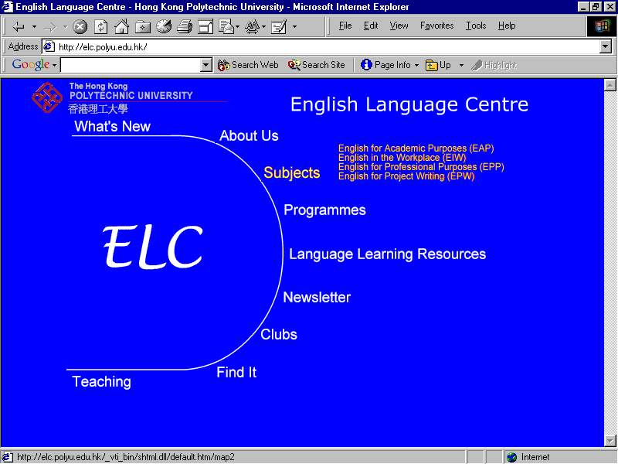
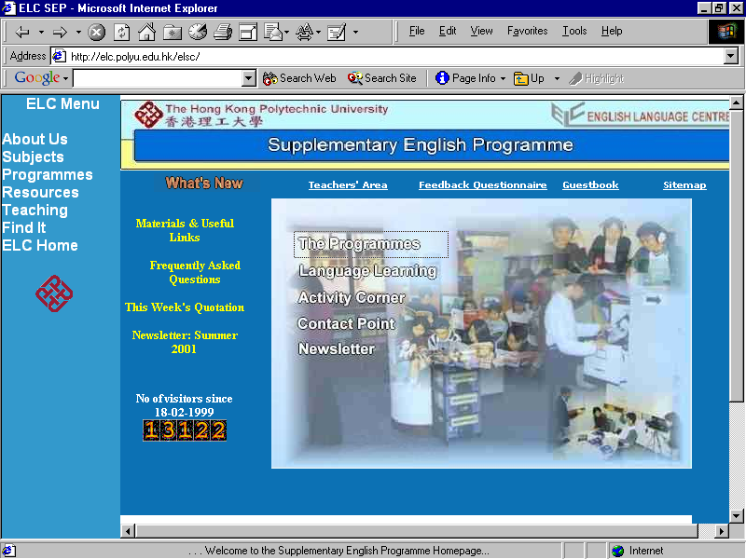
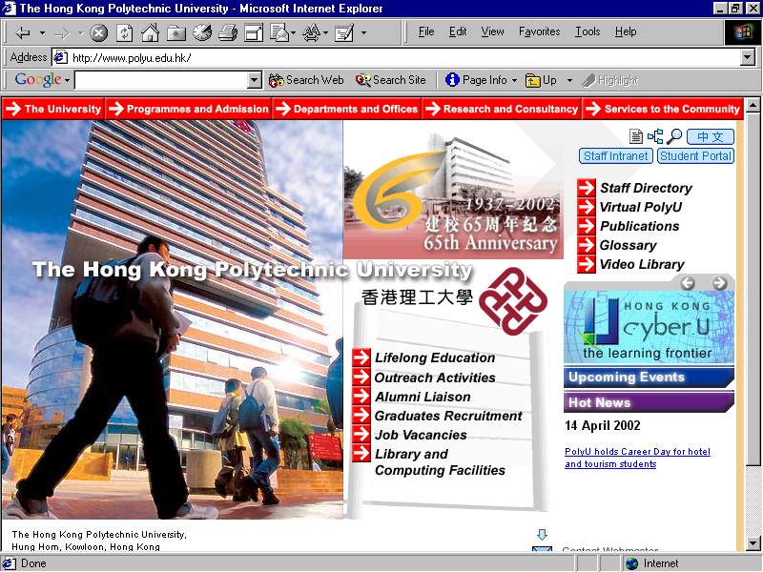
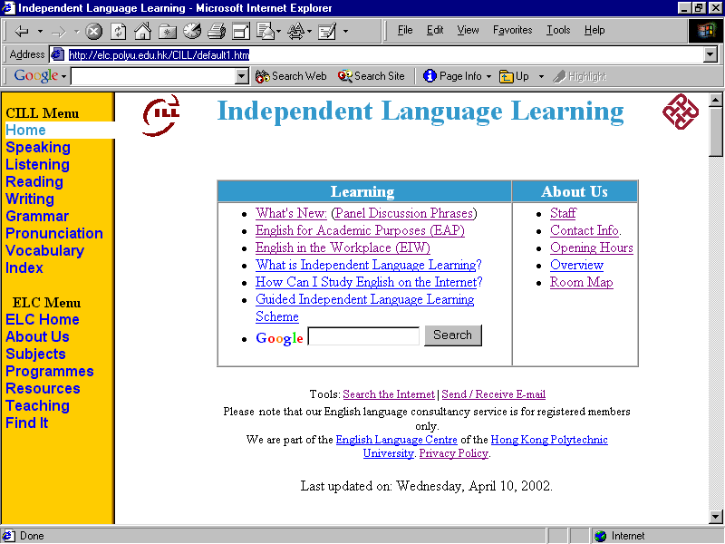
- Please circle the picture of the CILL site:

In your life, how many hours have you used: (Please tick once on each line)
Measures user’s expertise | 10,001+  hours | 1,001 -  10,000  hours | 101 -  1,000  hours | 11 – 100 hours | 1 second  –  10 hours | Never
2. the internet?
3. the internet for learning?
4. the internet for language learning?
5. the CILL site for language learning?

6. When did you last use the CILL site Please tick a box ☑  Is this a casual user?
a. In the last seven days □ b. Between 7 days and one month ago □
c. Between one and six months ago □ d. Over 6 months ago □ e. Never used it before □

7. What do you use the CILL site for? Please write down up to 10 things you do on the CILL website:

8. Do you have any suggestions for improving the CILL web site? Please write them here:

If you are a full-time HKPU student and would like to take part in testing the site, please write your e-mail address and mobile phone number here. This would be paid at Student Assistant rates, currently $46 per hour, and would involve one or two hours work.
E-mail: Mobile phone number:
Thank you for your help. Please return the questionnaire to the staff at reception.
Appendix Two: Usability Test Plan
References: Rubin, J. (1994, p.86) and Nielsen (1993, pp. 170-1).

Purposes
- To test the quality of the site, and improve it, if possible.
- To demonstrate CILL’s commitment to providing a quality service.

Test Objectives
- Can end users perform common tasks?
- Does the site contain usability flaws that prevent completion of common tasks?
(Modified from Rubin, J. (1994, p.86))

User Profile
See the profile of CILL students. Both novice and experienced CILL web site users were chosen.

Script (see Appendix 3)

Checklist

Welcome the participant and check their identity and profile.
- Explain the purpose and duration of the test (1 hour in total, including post-test questionnaire).
- Elicit any questions.
- Ask for consent for the participant to take part.
- Ask the participant to sign the consent form.
- Participant chooses the browser and version they usually use to access the CILL web site.
- The participant attempts to carry out the tasks.
- The participant either completes the final task or runs out of time.
- Give the participant a short break.
- Ask the participant to complete the post-test questionnaire.
- Chat about the test and the site
- Thank the participant for taking part.
- Participant departs.

Task List

Area of Enquiry | Task and Target URL
- Grammar | Find a grammar exercise on the difference between ‘staff’ and ‘staffs’.  http://elc.polyu.edu.hk/cill/exercises/staff.htm
- Pronunciation | Find out how to pronounce ‘thorough’.  http://elc.polyu.edu.hk/cill/pronunci.htm
- Vocabulary and  Newspapers | Find a page where you can learn vocabulary about the news.  http://www.bbc.co.uk/worldservice/learningenglish/news/index.shtml via http://elc.polyu.edu.hk/cill/vocabula.htm
- Listening | Find a page where you can learn English by listening to pop music.  http://www.bbc.co.uk/worldservice/learningenglish/music/index.shtml via http://elc.polyu.edu.hk/cill/listenin.htm
- Exercises,  Interviews  Speaking | Find a page with some common job interview questions and advice and an exercise about how to answer them.  http://elc.polyu.edu.hk/CILL/exercises/jobinterviewquestions.htm
- Dictionary | Look up the meaning of the word ‘discharge’’.  http://elc.polyu.edu.hk/cill/dictiona.htm
- Reference Machine and Referencing | Using a CILL web site page, make a correct bibliographic reference for a book with the following details:  Title: Better Academic English  Author: Smith, John  Year of publication: 2002  Place of publication: Hong Kong.  Publisher:  Hong Kong Polytechnic University Press.  http://elc.polyu.edu.hk/cill/referenceMachinebooks.htm
- Job Application Letter | Find a page which helps you to write a job application letter.  http://elc.polyu.edu.hk/cill/jal.htm
- Writing | Find a page where you can read about e-mail pen-pals you can write to.  http://www.bestmall.com/penpals/view.htm via http://elc.polyu.edu.hk/cill/writing.htm#Writing to E-mail Pen-pals
- Reading and  Newspapers | Find a page that helps you improve your newspaper reading skills.  http://www.bangkokpost.net/education/stutips.htm via http://elc.polyu.edu.hk/CILL/reading.htm#Newspapers

Note: ‘discharge’ is word 4921 in the list of most-frequently-used words from the Brown linguistic corpus (see http://www.edict.com.hk/lexiconindex/frequencylists/words2-5k.htm ).

Test Environment and Equipment

Equipment
Computer
Internet Browsers – Internet Explorer version 5, Netscape version 4, set to the CILL home page.
Script
Checklist
Task list

Appendix Three: Test Script

Test Script

Welcome to the CILL Internet site test.

The aim of this research is to make the CILL Internet site more easy for people to use.

I’m going to ask you to do a number of small tasks on the CILL site.

After that I’ll ask you to fill in a short questionnaire, and then we can chat about the site.

Based on the results of this test, and tests with other people who use the site, I’ll make some changes to the site, then do the tests again to see if the site is easier to use.

The site is not perfect, and any problems during the test are not caused by you, but by the site. It is these problems I want to find and solve. There is no pass or fail on this test, and your personal information will be kept confidential.

During the test, if you have problems, please try to solve them yourself. If you really get stuck, you can ask questions, but I would prefer you to explore the site and try to solve any problems yourself.

There is no time limit or target time for the test.

Please feel free to talk during the test, especially about what you are thinking. This will help me to improve the site.

Do you have any questions?

Before we start the test, I would like you to read and sign this consent form. This is a standard form we use in research to tell you that the test will not hurt you, and that you can stop the test at any time.

(Participant reads and hopefully signs the consent form)

What browser would you like to use?

(Participant does the tasks)

(Participant fills in the post-test questionnaire, including suggestions)

(Chat about the test)

Thank you for taking part in the test. It was very interesting and it will help me to improve the site.

Appendix Four: Consent Form

A Usability Study of a Language Centre Web Site

Welcome to "A Usability Study of a Language Centre Web Site," a web-based experiment that examines the usability of the web site of the Centre for Independent Language Learning. Before taking part in this study, please read the consent form below and sign it at the bottom of the page if you understand the statements and freely consent to participate in the study.

Consent Form
This study involves a web-based experiment designed to test the usability of the web site of the Centre for Independent Language Learning (CILL). The study is being conducted by Mr. Andy Morrall of the Hong Kong Polytechnic University.

Participation in the study typically takes 60 minutes and is strictly anonymous.

The test involves doing some short tasks. These tasks involve finding web sites for learning English, starting from the CILL site. This is not a test of participants’ ability, it is a test of how user-friendly the CILL web site is.

I understand that my participation is completely voluntary, and that I am free to withdraw from the study at any time I choose, without penalty.

I understand that no deception is involved, and that this project is not expected to involve risks of harm any greater than those ordinarily encountered in daily life. I also understand that it is not possible to identify all potential risks in any procedure, but that all reasonable safeguards have been taken to minimize the potential risks.

I understand that the results of this project will be coded in such a way that my identity will not be physically attached to the final data that I produce.

I understand that the results of this research may be published or reported to universities, government agencies, funding agencies, or scientific groups, but that my name will not be associated in any way with any published results.

I understand that if I have further questions about this study or my rights, or if I wish to lodge a complaint or concern, I may contact the principal investigator, Mr. Andy Morrall, at 2766 7575 or ecandym@polyu.edu.hk.

Please sign here: ______________________________

Please write your name clearly here: ____________________________

Appendix Five: The Post-test Questionnaire for Round One

Post-test Questionnaire

In your life, how many hours have you used: (Please tick once on each line)
Measures user’s expertise | 10,001+ | 1,001 - 10,000 | 101 - 1,000 | 11 - 100 | 0 – 10 | Zero
1. the internet
2. the internet for learning
3. the internet for language learning
4. the CILL site for language learning

5. When did you last use the CILL site (not including this test)? Please tick a box ☑
- In the last seven days □ Is this a casual user?
- Between 7 days and one month ago □
- Between one and six months ago □
- Over 6 months ago □
- Never used it before □

Please indicate the degree to which you agree or disagree with the following statements about the site (Please tick once on each line):
Measure subjective satisfaction – use 5-point scale for comparison to literature Nielsen 1993 p.35
 | 5  Strongly agree | 4  Agree | 3  Neither Agree or Disagree | 2  Disagree | 1  Strongly disagree
6. It was very easy to learn  how to use this site. | 5 | 4 | 3 | 2 | 1
7. Using this site was a very frustrating experience. | 1 | 2 | 3 | 4 | 5
8. This site is very  pleasant to work on. | 5 | 4 | 3 | 2 | 1
(Reverse the results for Q7 to calculate average satisfaction)

9. Please write any comments or suggestions here:

Thank you for taking part in this research.

Appendix Six: The Post-test Questionnaire for Round Two – Repeating Participants

Post-test Questionnaire – Participant’s Second Test

Please indicate the degree to which you agree or disagree with the following statements about the CILL Internet site (Please tick once on each line):
Measure subjective satisfaction – use 5-point scale for comparison to literature Nielsen 1993 p.35
 | 5  Strongly agree | 4  Agree | 3  Neither Agree or Disagree | 2  Disagree | 1  Strongly disagree
1. It was very easy to learn  how to use this site. | 5 | 4 | 3 | 2 | 1
2. Using this site was a very frustrating experience. | 1 | 2 | 3 | 4 | 5
3. This site is very  pleasant to work on. | 5 | 4 | 3 | 2 | 1
4. I remembered how to complete the tasks from the first test. | 5 | 4 | 3 | 2 | 1
5. This site is easier to use than in the first test. | 5 | 4 | 3 | 2 | 1
(Reverse the results for Q7 to calculate average satisfaction)

These questions are about how you use the Internet (not just on the CILL site).

When looking for information on a site:
 | Very often | Often | Sometimes | Rarely | Never
6. I use the browser’s ‘Find’ function to find a word on a page.
7. I use the Site Search function, if there is one.
8. I use the Site Map
9. I use the Index
10. I browse for any useful information.
11. I search for specific information

12. Please write any comments or suggestions here:
Thank you for taking part in this research.

Appendix Seven: The Post-test Questionnaire for Round Two – New Participants

Post-test Questionnaire – 2nd Round

In your life, how many hours have you used: (Please tick once on each line)
Measures user’s expertise | 10,001+ | 1,001 - 10,000 | 101 - 1,000 | 11 - 100 | 0 – 10 | Zero
1. the internet
2. the internet for learning
3. the internet for language learning
4. the CILL site for language learning

5. When did you last use the CILL site (not including this test)? Please tick a box ☑
- In the last seven days □ Is this a casual user?
- Between 7 days and one month ago □
- Between one and six months ago □
- Over 6 months ago □
- Never used it before □

Please indicate the degree to which you agree or disagree with the following statements about the site (Please tick once on each line):
Measure subjective satisfaction – use 5-point scale for comparison to literature Nielsen 1993 p.35
 | 5  Strongly agree | 4  Agree | 3  Neither Agree or Disagree | 2  Disagree | 1  Strongly disagree
6. It was very easy to learn  how to use this site. | 5 | 4 | 3 | 2 | 1
7. Using this site was a very frustrating experience. | 1 | 2 | 3 | 4 | 5
8. This site is very  pleasant to work on. | 5 | 4 | 3 | 2 | 1
(Reverse the results for Q7 to calculate average satisfaction)

Please turn over >>
These questions are about how you use the Internet (not just on the CILL site).

When looking for information on a site:
 | Very often | Often | Sometimes | Rarely | Never
9. I use the browser’s ‘Find’ function to find a word on a page.
10. I use the Site Search function, if there is one.
11. I use the Site Map

12. I use the Index

13. I browse for any useful information.
14. I search for specific information

15. Please write any comments or suggestions here:

Thank you for taking part in this research.

